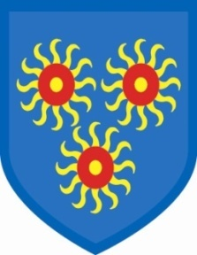
St Edmund’s Catholic Primary School

20th July, 2018

We are very pleased to inform you that the Year 6 children have gained excellent SATs results, with 96% passing Reading, 92% passing Grammar, Punctuation and Spelling and 92% passing Maths. We are very proud of them and we wish them continuing success in their chosen secondary schools. This year the children are going to Bishop Challoner, Canary Wharf College, St Michael’s Catholic College, St Ursula’s, George Green and Phoenix.
We are also saying goodbye to Ms Ferguson, who has been at the school for many years, as she leaves to pursue other interests.
Classes next year are as follow:-
Year 6 Ms Collie
Y5 Ms Sapsford
Y4 Mr McKenzie
Y3 Ms Beker
Y2 Mr Ramesar
Y1 Ms John
Reception Daniel Walrond
Nursery Maria Charles

We say congratulations to Holly, who gave birth to a healthy boy, weighing 8lb 6oz!

Finally, the governors and staff of St Edmund’s wish you all a very happy and peaceful summer – enjoy it wherever you are.

See you all on Wednesday, September 5th.

