From Advent to Christmas Year B  Linking School, Parish and Home |  |  | 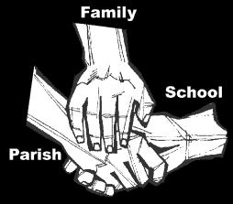
Religious Education
Key Idea: From Advent to Christmas
This topic is intended for the second in the academic year 2018/2019. As the days shorten and winter comes upon us we are invited to consider the light of Christ who came into the world at Christmas. As the Gospel of Mark has no story of the birth of Jesus, this topic looks at who Christians around the world celebrate the coming of God into the world.
Attitudes and Spiritual Dispositions
Spiritual Outcomes: It is hoped that pupils will develop:  - A sense of the importance of prayer  - A willingness to pray | - An attitude of respect for the many traditions of Christmas  - Appreciation for the gift of God at Christmas
Activities to try at home
You are the first educator of your child in faith. Your child’s learning in religious education will be much greater if you and the school are engaged in talking about the same ideas and beliefs. Help your child by trying this activity while this topic is being taught:
- This topic focuses on how different cultural groups celebrate Christmas. Talk to your children about any particular practices you and your family might have, particularly if, and how, your culture might be evident in what you do. If you can, encourage your children to share your cultural customs with their peers at school.
An idea for prayer at home
Prayer Activity
Loving God, you created people full of dignity still more wonderfully restored our dignity when we failed. At this time of Advent help us remember Jesus who humbled himself to live like us, so that we might be able to share his divinity. We ask this through Christ who lives and reigns with you in the unity of the Holy Spirit, one God, for ever and ever. Amen
Adapted from the Opening Prayer of Christmas Day Liturgy.

