Weekly plan for Caterpillars (4t^{h} –8th May)
Dear parents/Carers,
I have tried to design this timetable to make it as fun as possible for you and your child. I have put examples to guide you, however, please feel free to use your imagination and go for it! Here is a rough timetable for you to use with your child if you have the time. We understand the pressures you are under and this is optional – it is just to support you as you spend time with your child. It is also important to remember that your child needs lots of brain breaks and opportunities for play (we know you know this)– role play, gardening (if this is possible), outside exercise (again, we know the limits), baking, drawing, painting etc..Also, obviously feel free to do these activities when they suit you – you do not have to stick to the times on the timetable.
 | 9am – 9.20am  Literacy | 10am – 10.15am  Phonics | 11am- 11.20am  Maths | 1.30-1.45pm | 2.30pm – 3pm
Monday | New topic, Minibeasts. Follow the link for the book, Bugs,bugs, bugs.https://www.youtube.com/watch?v=pF8e1Bw90e4  Discuss with your child what type of book this is. It is an information book. What is an information book? What have you learned about the bugs in the book?  -Practise name writing each day. Remember to encourage your child to hold the pencil correctly. | - Adjust the volume. -2 people sit opposite each other and copy each other with loud and quiet sounds. This is so much fun - be as silly as you like. Your child will love this activity! | - If you have some board games play them as a family e.g snakes and ladders. If you do not have snakes and ladders make a simple grid on paper and play. There are lots of examples online. | - Watch the link, Facts on Bees.  .https://www.youtube.com/watch?v=OiJdfF40p-Q  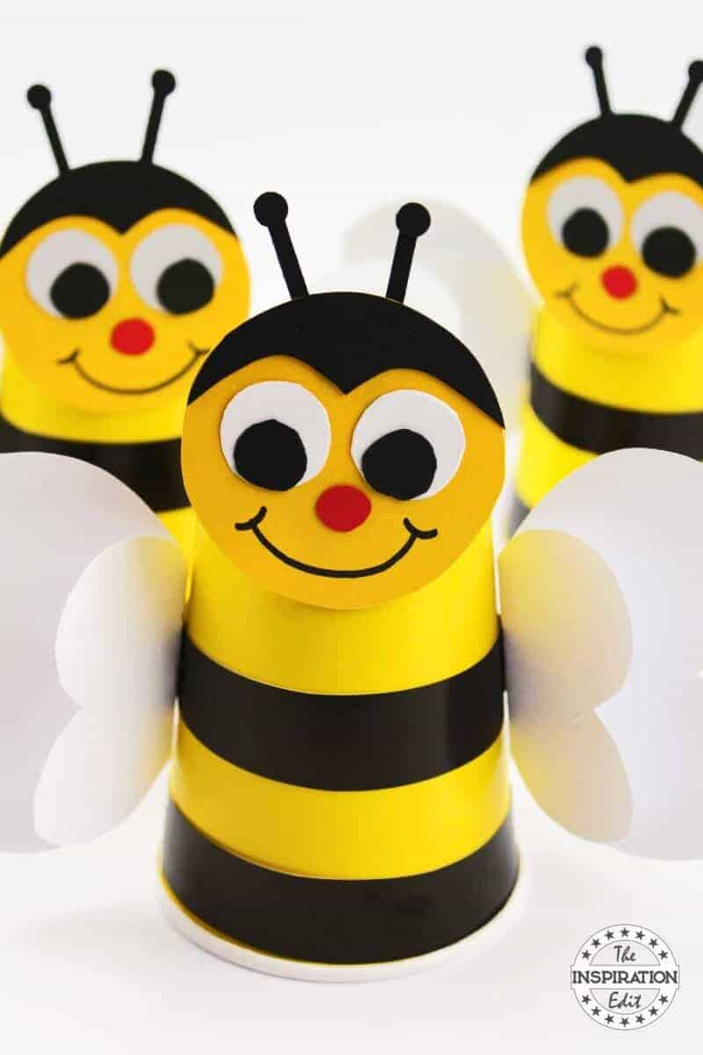  Make a bee using a paper cup or any recycle material you have. What colour is the bee? Take photos to share with class in the future. | -Have a bit of quiet time together if possible. Read a story and share a snack or two together.  Story time is especially important for your child.
Tuesday | -Practise name writing in the exercise book sent home. Write their name on a piece of paper first and ask them to copy it. Write with highlighter pen if they want to copy over a model.  -We have read “Bugs, bugs, bugs. This is an information book that teaches us facts (what are facts?). Choose one of the bugs you liked in the book and draw it in your book. Did you learn anything new about the bug you chose? Write about what you have learned in your book too. Tell your grown up what you have written. Parents encourage your child to read you their sentences. Remember lots of praise. | Target sounds. Give each person a target sound to put into a story. (e.g, when they hear the word train) start with a single sound that a small group can make together. When they hear the word then they make the sound.  Play this as a family -it’s great fun. | - Cut out 2D (flat) shapes for your child. Triangle, rectangle, square, circle, pentagon and hexagon. Ask your child to name the shapes. Then use the shapes to make bugs. Ask your child to name each shape they are using. . | 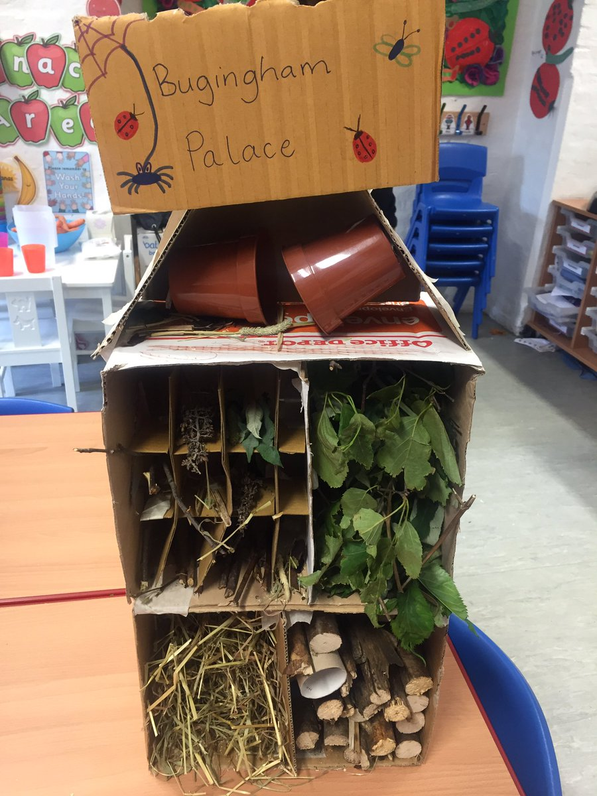  This activity is a messy one! You are going to make a bug hotel!! How fantastic. Use any recycled materials you have in your home. When you go on your daily walk look for leaves, twigs etc. - whatever you like. Remember - bugs love a bug hotel. | Watch Jesse the minibeast teacher on the link teaching you all about bugs.  https://www.youtube.com/watch?v=JuHg5oWF_mo
Wednesday | 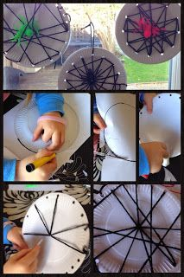  - Make a spiders web. Use any materials you have in the house. The photo is only an example. Make the spiders web however you choose. You can even make little spiders to hang from it.  Scare your grown ups! | Target sounds. Give each person a target sound to put into a story. (e.g, when they hear the word train) start with a single sound that a small group can make together. When they hear the word then they make the sound. | Play number snap. Make lots of small paper squares from 1-10. If you want a challenge 11-20. Depending on your child. Make sure your child can recognise the numbers. Practise saying the numbers before you start the game. | -Baking. Make bug biscuits with your child. Use the simple Mary Berry recipe from last week. Make your bug biscuits any shape you like, size etc. go for it and have fun. | - Take all your cushions, pillows and make a comfy space. Include your child’s favourite toys. Read together.
Thursday | - look at the books your child has at home. Ask them to choose a book to look and read to them. Ask them questions about the story. Use the Oxford Owl books online if you have read all your books at home.  Look at the parent curriculum map for stories we are reading this term. | -Use a mirror and make all the sounds you have been using this week. What does your mouth look like? Do you look funny? Explore how your mouth changes shape when you make a variety of sounds. | -Sing some number songs with your children.  You tube has a variety of number songs. Sing number songs each day.  Ask your child to teach you 5 little fishes in the sea. It’s their favourite. | From Easter to Pentecost- Talk about a group in the Diocese of Westminster – a group called Caritas. Explain that the word caritas means ‘kindness to other people.’  ‘Caritas’ group reminds us to tell the older people in our lives that we care for them. Make cards for older people in your child’s family, their grandparents, etc | -Have a bit of quiet time together if possible. Read a story and share a snack together.
Friday | -Practise name writing in book.  -If you were a bug what kind of bug would you be? Scary? Big? Small?sliimy? hairy? Use your imagination to make your own bug. Write down all the things you would like in a bug. Ask your child to write this down in their book. NB- ask them to use THEIR writing – which will be a mixture of mark making and letters – then to draw a picture. | - on your walk today what sounds can you hear? Talk about the sounds? Do you like them all? Which sounds do you not like? Ask your grown up to write all the sounds that you can hear down for you. | Use any of your child’s toys to count for this game. Put lots of toys in the middle. Roll a dice and count how many. Then ask your child to count that many toys. You can go as high as you like. If you want a challenge cover the spots and put numbers on the dice. Remember you can use your phone app for a dice. Have fun! | -Use your schoolbook to draw a Bee. Remember the video you watched, Bee facts. Can you write down 4 bee facts? Tell your grown up all the facts you now know. | Follow the link and read, Guess how much I love you. https://www.youtube.com/watch?v=2aep8wNHGto  Talk about families and what it means to you. Families come in all shapes and sizes.

