From Easter to Pentecost - Year B  Summer A  Linking School, Parish and Home |  |  | 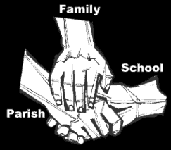
Religious Education
Key Idea: From Easter to Pentecost
This resource is intended for the Summer Term of 2017/2018 and its focus on Easter and Pentecost. In previous years pupils have focussed on Pentecost as a Jewish celebration recorded in Acts of the Apostles and as a Liturgical feast, 50 days after Easter. This resource picks up the actions of the disciples as models for our behaviour now by listening to people we might call Pentecost People today, for whom faith is important, including Cardinal Nichols.
Attitudes and Spiritual Dispositions
Spiritual Outcomes: It is hoped that pupils will develop:  - An appreciation of the many people who live in response to their faith  - An awareness of the importance of faith in life | - An openness to the impact that faith can have on their own decisions and actions  - A willingness to respond to the personal call to faith which is theirs
Activities to try at home
You are the first educator of your child in faith. Your child’s learning in religious education will be much greater if you and the school are engaged in talking about the same ideas and beliefs.
- How you live matters to your children. You model what is important in life and what you consider success is. Faith may be part of your life. If it is talk to your children about how you express your faith and why it makes a difference to the way you live.

An idea for prayer at home
Prayer Activity
Pray:
Loving God. In the people around us we see your love and care. In the people around us we see your forgiveness and gentles. In the people around us we see your justice. Help us to be Pentecost People in our day to all those around us.
We ask this through Jesus who lived to show us how to live.
Amen.

