What We’re Doing (Activities) –
Week Beginning: Monday the 11th of January

Daily Activities
Book of the Week: Elmer and the lost Teddy
Weekly Song or Rhyme:
https://www.bbc.co.uk/teach/school-radio/nursery-rhymes-clap-clap-hands-one-two-three/zkrcf4j
Let’s Get Physical:
Some form of physical exercise that raises your child’s heart rate, makes them breathe faster and feel warmer. Dance/ PE with Joe Wicks/Getting outside to the park/time on a bike or scooter/yoga stories for kids online
Play: Spend some time playing with your child at an activity they have chosen. This is a perfect opportunity for being imaginative and developing lots of language.

Dear Parents,

How are you all? How did you get on with last week’s plan? I hope you found it straightforward, manageable, accessible and above all fun! We continue with another Elmer book this week so this is a great opportunity to recall the previous story and compare it to this one. What is the same, what is similar and what is completely different? Do you have any other books at home where they have the same character in each book? Do they take place in a jungle like the Elmer stories? Do you have a favourite story? What is it about the book that you like so much?

We need to show the children real world reasons for why we read, write and use numbers so please get busy writing shopping lists, reading recipes or instructions or even reading your own book at the same time as the children enjoy theirs. Write a note for the neighbour, a poster for the window…a thank you note for a gift. Have fun!

Reading: Choose a story for your grown up to read to you. After they have finished talk together about the story. What happened? Who was in the story? Did you like it?

Monday
Get moving: Let’s get out side! Can you get your heart pumping?! Run, Jump, play with a ball…

Literacy: Read- our story of the week- Elmer and the Lost Teddy. Before watching look at the front cover and ask your child what they can. What do you think this story is about?
https://www.youtube.com/watch?v=oYf7Ehx4IHw
Expressive arts & Design :
Can you use your blocks/lego/construction toys to build a home for an animal from the story?
What does the animal need to be safe and happy? Can you tell your grown up about your home?

Maths- Dice and towers. Can you roll a dice and build a tower of that number? Take turns. See if you can match your number card to your tower.
(There are online dice if you don’t have any at home)

Name writing-
Please have a go at writing your name.
Parents you can write one letter and your child writes one etc
You could write it under a picture you have drawn. Don’t forget about letter formation, trying to hold the pencil and holding the paper still.

Tips: Dice teaches a great skill of subtising an amount, quickly. E.g. seeing an arrangement of 4 dots as ‘4’ without having to count every time.
You might find that they need to count each time until they get the hang of it.
Also: playing games make it fun and you learn lots of skills about winning and loosing and taking turns.

RE: Time to pause and reflect. Have some quiet time. Some of us may like to pray. Let’s think of our families, our friends and those who are helping us in lots of different ways. Can you draw a picture of them and tell your grown up about them?

Phonics: Can you draw a simple set of objects that rhyme e.g cat, bat, mat, hat, rat. Tell your child what they are and lay them down on the table. Put a bowl on the table and a spoon. Say this rhyme with your child “ I’m making lots of silly soup. I’m making soup that’s silly. I’m going to put it in the fridge to make it nice and chilly.” Ask your child to put one picture in the bowl and stir it. Repeat the rhyme each time and add one more picture – saying the rhyming objects once they are in the bowl.

Physical Development: Get moving: yoga stories for kids:
https://www.youtube.com/watch?v=C4CaR0syf1g
Tuesday

Expressive Arts & Design:
Teddy is lost. Can you help the baby elephant find Teddy?
Perhaps you can draw a map through the jungle?

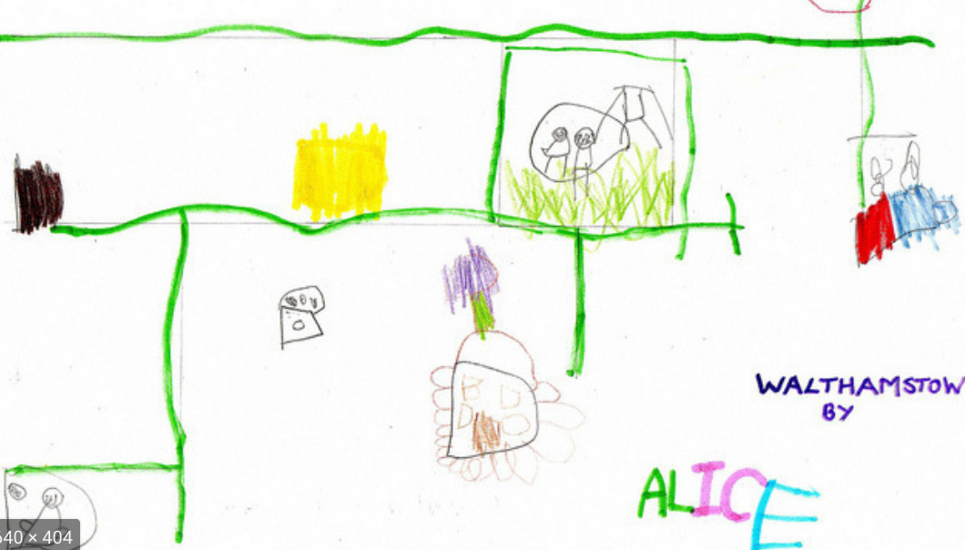
Maths-
Use your number cards. Turn over a card and do that many:
Jumps or hops or spins or wiggles.Can you think of your own movements?
Don’t forget to stop when you get to the number on the card. Can you now put the number cards in the correct order? If your grown up mixes two up can you put them back in the right place?
Name recognition- please write the names of everyone at home on pieces of paper - can you find your name from a selection of names?
Talk about: what you look at to help you find your own name? What letters are the same in the names? How many letters in each name? How would you find out? Who’s name has the most letters?
This is a great opportunity to sort and compare the names in different ways.

Understanding the World-
Have a look at a real map. What do you notice? What do the different colours show us? Can you name any of the places on the map? Where would you like to visit and why would you like to go there? Can you draw a map for it?
Literacy: Story focus: Watch the story ‘Elmer and the Lost Teddy’ again
Elmer hears crying: why is baby elephant crying? What does Elmer do to help the little elephant? What would you do? Which animals in the story try and help? The teddy says; ‘Help! Help! I am lost.’ How does the teddy feel? Have you ever been lost? Practise what to do if you ever get lost. Can you use your writing (this is mark making – ask your child to hold the pencil and “use their writing” – whatever marks they make is their writing. Ask them then to read their writing to you) to tell me what your favourite animal is? Can you draw a picture too?
Mark making is the first stage of writing. Children will make marks on the page (not recognisable letters at first) and we ask them to read us what they have written. We really celebrate this too!

Phonics: Can you go on a sound walk with your child? Go outside and stop – maybe close your eyes. What can you hear? Talk together about all the things you can hear. Can your child draw a picture of them?

Physical Development: Get moving: Joe Wick’s PE slot on a Mon/Weds/Fri. A great way to feel connected to lots of other people getting active across the world! https://www.youtube.com/user/thebodycoach1/videos

If you have some tube pasta and string can you ask your child to thread the pasta onto the string to make a necklace for Elmer?
Wednesday

Religious Education

We have just celebrated
Christmas and the birth
of Jesus. We know from the Nativity story about the Wise Men who travelled across the desert to visit Jesus and his family when he was born. They also brought Jesus gifts.
Think about a time when you have given or been given a gift. What was it like? How did it feel?
The wise men were guided across the desert by a special star. Can you see any stars? When do you see stars?
Can you make a star to decorate your window? This might help you think about the arrival of Jesus.
Maths- have a go at collecting some natural treasures from the park as shown below. Just make sure you are safe and wash your hands afterwards. Can you count how many and match with a correct number card?

Can you order the number cards from earlier in the week?
Literacy: Story focus – where does the story happen? Can you describe it? Can you make a picture and match the colours and shapes you see?
Are the leaves curved or straight? Are they jagged or pointy? Can you find any plants or trees like that in the local park? What shaped leaves can you spot?

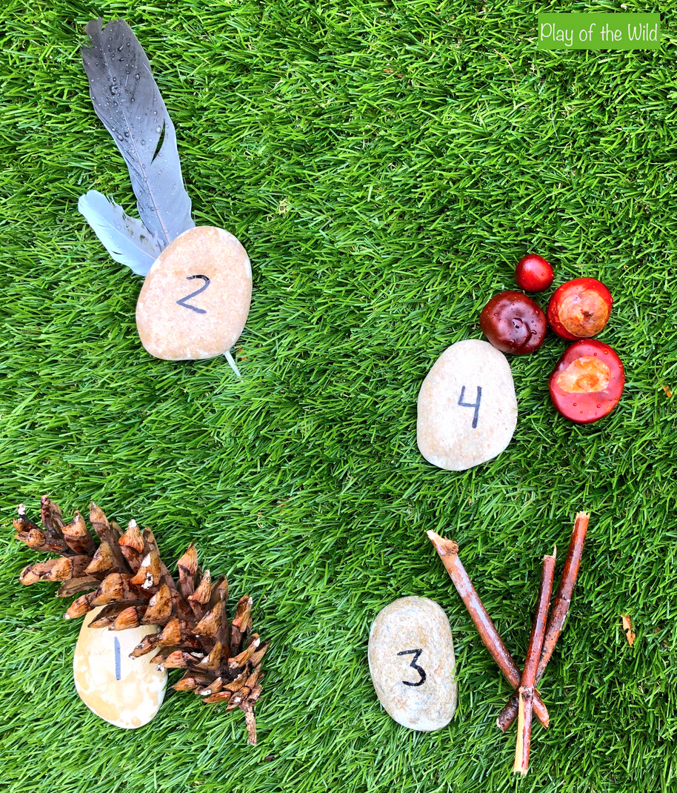

Phonics:
Tuning into everyday sounds. Watch this with your child. Pause the video after each sound. What can you hear?
https://www.youtube.com/watch?v=h0Kp_J9kvNM

Physical development: Get moving: here’s a song to shake your sillies out to
https://www.youtube.com/watch?v=NwT5oX_mqS0_o

If you have some paper, pencils and scissors at home: Ask your child to draw some grass. Ask them to then use the scissors to snip the paper to cut into the grass. Support your child whilst using scissors so that they use them safely. Can your child finish their picture by drawing Elmer?

Expressive arts + Design do you have any grains/oats/flour/rice /dried pulses for ‘messy play?’

Put some into a large tray with some spoons or scoops and small boxes or empty containers.

Let the children explore.

You can store these and use it again if it stays dry.

This is a really nice sensory activity but uses lots of coordination/motor skills.
You could add some toys in to extend it.

Thursday
Maths-
Today’s number fun is linked to the creative activity- You can compare how many spoons fit into different containers. Which holds more/ which holds less or a fewer number of scoops?

Elmer was looking for the lost teddy.
Can you help him by making a lost poster? Can you write your name on your work? Ask your grown up to write your name and you can copy it.

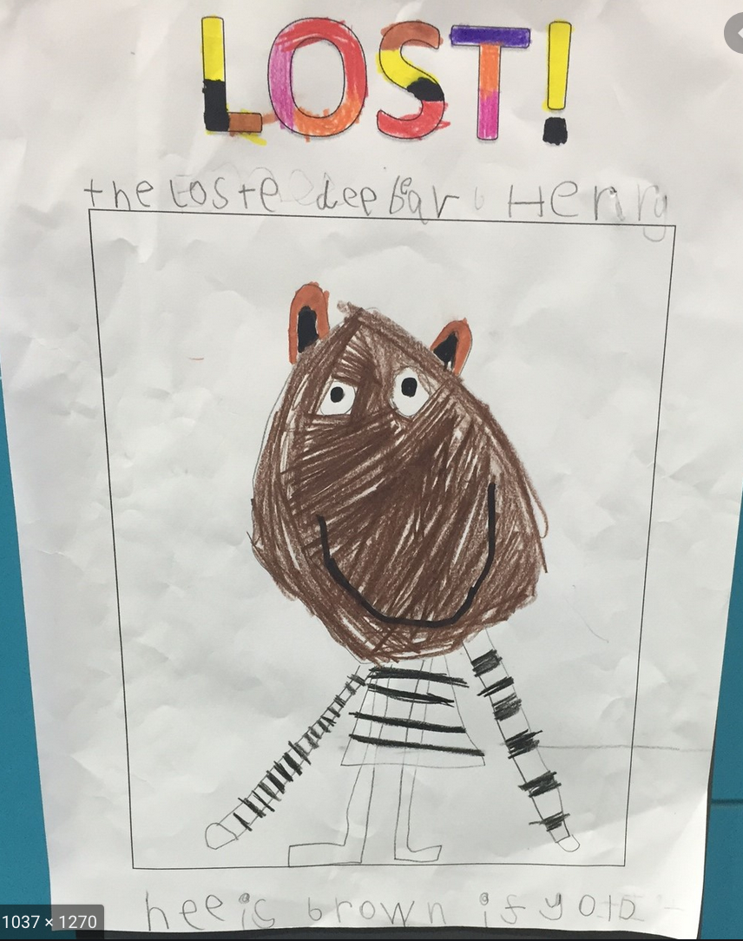
Reading-
Choose a story and read together with some yummy snacks. Can you now tell your favourite Teddy about the story?

Phonics
Play a simple rhyming game- clap three words – cat,bat,mat then ask your child to repeat back to you.
Try with others –
Pot, cot, dot.

Do not worry if the words are made up words – the important bit is the rhyming!

Physical Development: Get moving: yoga stories for kids:
https://www.youtube.com/watch?v=C4CaR0syf1g_uw
Can you draw some thick straight lines on a piece of paper and ask your child to try and cut along them? Support your child. They can then turn one into a book mark!
Friday

Story focus- In the end Elmer finds Teddy. Who helps him? Can you describe Elmer’s helper?
They have done something nice for the baby elephant. How does the baby elephant feel when he gets the teddy back?
Can you think of things that you can do to make other people feel happy?
Choose at least 1 thing and do it. Can you draw a picture of what you did? Can you use your writing like earlier in the week to write it too? (mark making).
Expressive Arts & Design

Can you make a mask?
Here is a link for how to make an elephant mask. You can choose what kind of mask you’d like to create.

https://www.youtube.com/watch?v=MPoNV4SdNiY

Maths- Can you use your teddies for some counting?
Put some teddies out – count them. Take some away – will there be more teddies there or less? What if you put more teddies now? Match the totals with your number cards.

Religious Education – revisit the Nativity Story. Do you remember any ‘helping’ that happened? Who helped who? When someone helps you, we like to say thank you to show we are grateful and that we care. Let’s give thanks to others who are helping us. Some of you might like to pray. Try to remember to say ‘thank you’ when you are helped.

Phonics:
Can you think of a few alliterative sentences to say with your child?
E.s silly Susan sat on a sausage!
Round Roly rolled on the roundabout!

