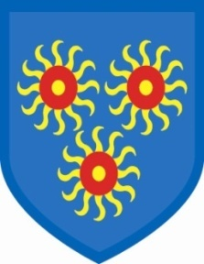
St Edmund’s Catholic Primary School

3rd May, 2019
Polling – We have a difficult situation arising due to the extension of Brexit! If an agreement is not reached, the country has to hold MEP (Member of the European Parliament) elections. We are a polling station and we have been informed that we must be prepared to close on May 23rd for the MEP elections. As all the political parties have started campaigning, we are assuming that we will be closed on May 23rd. We will keep you informed of the situation as and when we receive further information.

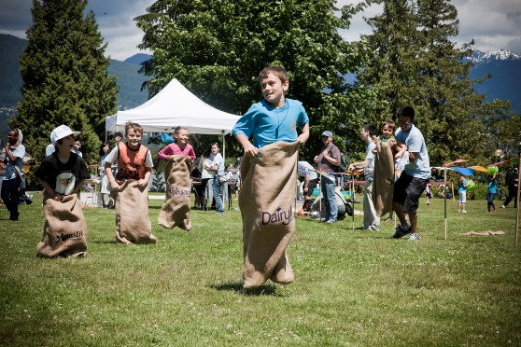
May 23rd is when we have planned to hold our Sports Day. We can only have Sports Day if the weather is good as Mudchute Farm cut the grass in their field for us and grass cannot be cut when it is wet. (Grass is also very slippery if it is wet.) If the weather is on our side, we would still like to hold Sports Day on May 23rd. However, we cannot have children coming to the school. You will have to take your children to the field and stay with them to take them home at the end of the day. We will take all the equipment and set up as usual, but we will meet you all in the field. We cannot bring children back to school. All children will have to be taken to the field, in their PE kit, and collected by their adults. Sports Day starts at 1.15pm in the field on Mudchute Farm.
Please keep an eye on our website and twitter feed for further updates.

