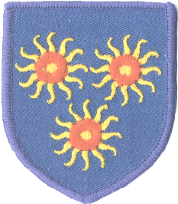

St Edmund’s Catholic Primary School

Diocese of Westminster

[www.st-edmunds-school.org/website](http://www.st-edmunds-school.org/website)

**Follow us on @stedmundsschoo1**

Newsletter to Parents Thursday, 6th October 2022

Year Two Learning

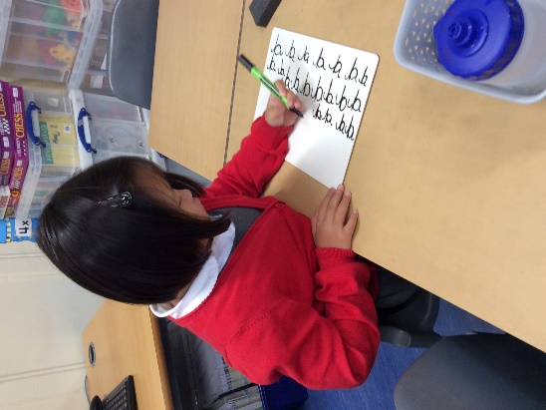

We are practising our cursive handwriting.

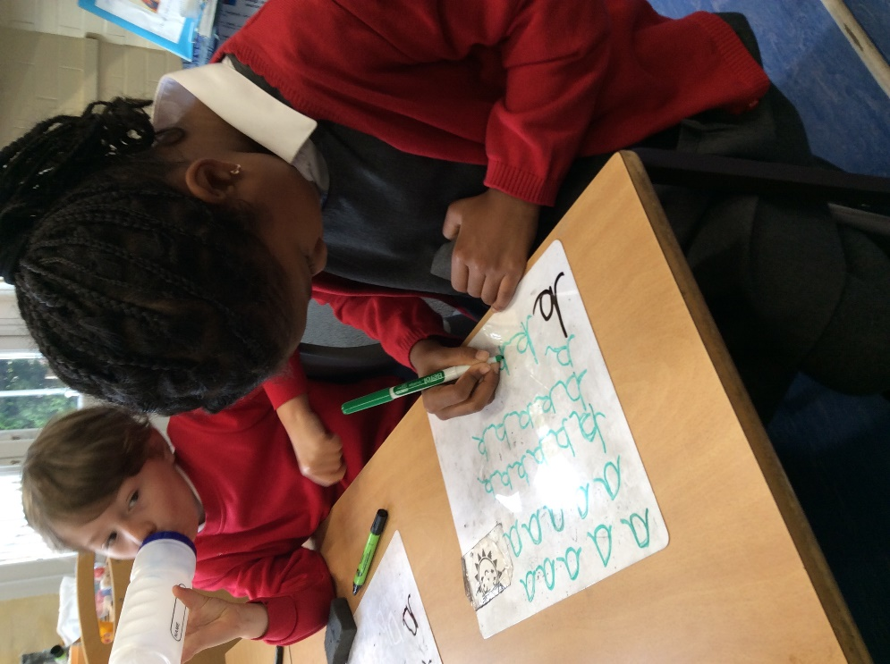

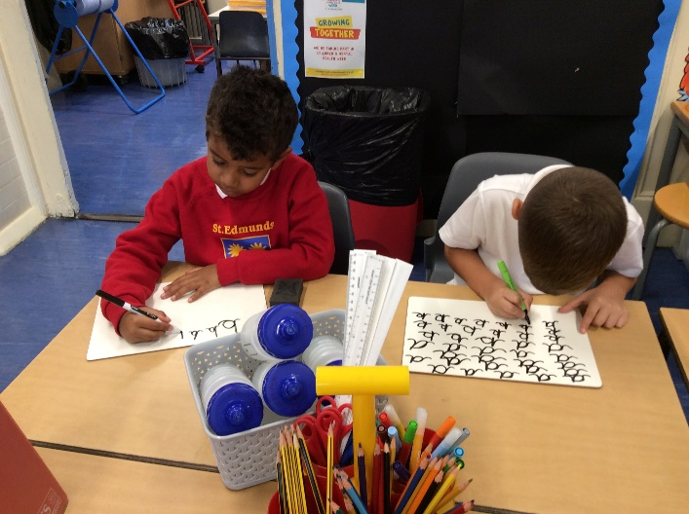

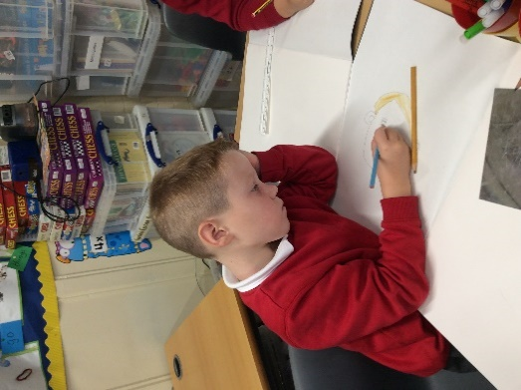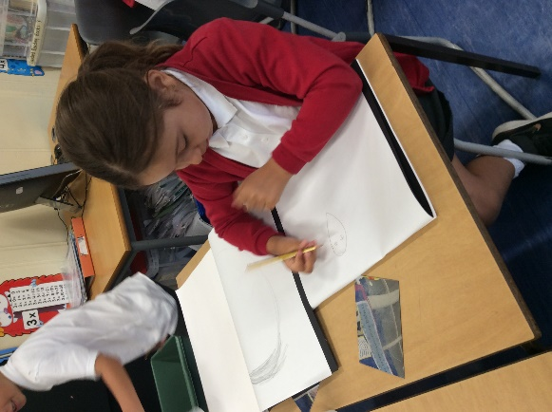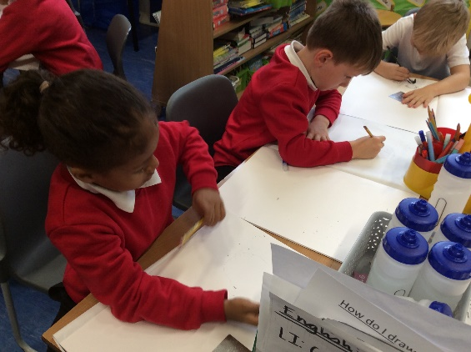

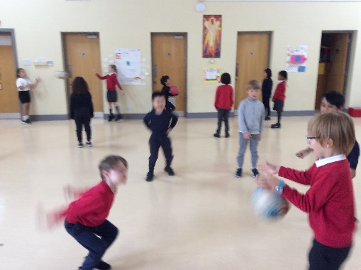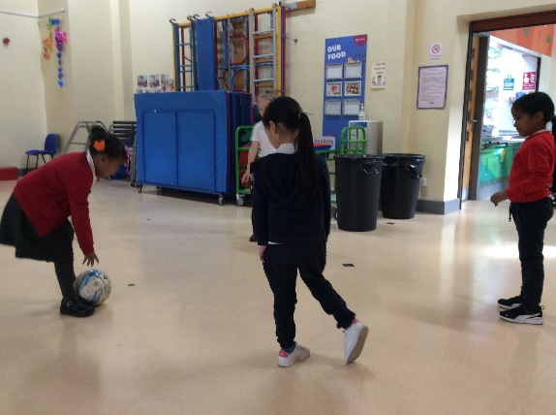

For PE we are learning how to control the ball, using our hands and feet.

For our Art topic, we have been learning about famous portraits and drawing our own!

**Class Assemblies**



**Here are the dates for the upcoming class assemblies:**

Thursday, 13th October: Year 3

Thursday, 20th October: Reception

Assemblies start at 10.10am in the hall and finish by 10.30am.

**What do our students say about their learning?**

**Y2** –I have liked the different kinds of Maths, counting in 3s-Antonis.

**Y2** – Good!-Michael

Y2-I like when we do our faces in Art!-Milan

Y2-We get to learn a lot of things.

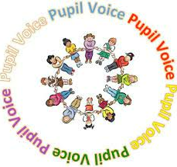

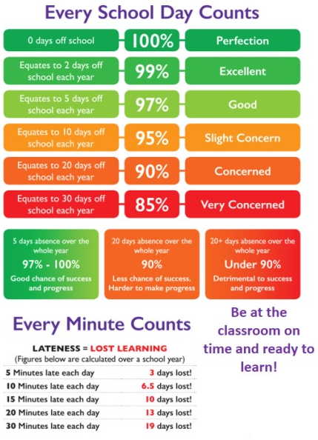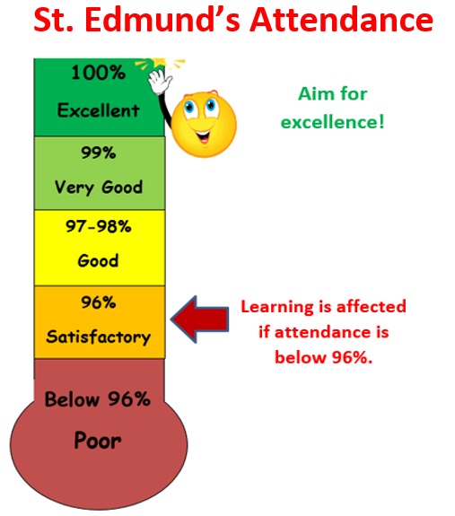

Our target it to get our attendance back up above **96%**.

**Whole School Attendance** – **93.71%**

**Best Class Attendance**

23rd September – Nur – 100%

30th September – Reception – 98.66%

6th October – Year 4 – 96.92%

Each week we will be sharing and celebrating the class with the **highest attendance** or the **most improved attendance**.

The class that achieves this award will make healthy smoothies. We understand that some children are unable to attend school every day for various reasons, and we will continue to support them and celebrate their attendance too.



**St. Edmund’s Safeguarding Information**

Safeguarding

Safeguarding and keeping our children safe are very important to us. If you have any suggestion on how we can improve on our safety measures, please do speak with Mrs Savva-Brown.

If you have any concerns about any child’s safety or child protection, please see

**Mrs Savva-Brown, the school’s Designated Safeguarding Lead – Headteacher ASAP.**

If she is not available, please see another member of the safeguarding team.

**There are photographs of the Safeguarding team placed in each classroom, please talk to your children and encourage them to talk to the adults in school if ever they need to.**

For information on Safeguarding, please see the Tower Hamlets multi-agency safeguarding hub website.

[*https://www.towerhamlets.gov.uk/lgnl/health__social_care/children_and_family_care/Multi-Agency-Safeguarding-Hub-MASH.aspx*](https://www.towerhamlets.gov.uk/lgnl/health__social_care/children_and_family_care/Multi-Agency-Safeguarding-Hub-MASH.aspx)

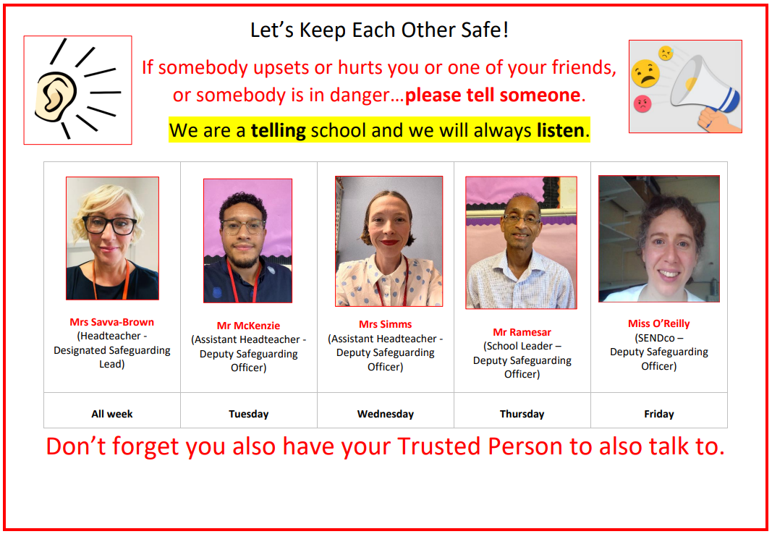

**What do our students say about safeguarding?**

**Y2** – We have the poster on our door!-Hazel

**Y2** –If you tell them someone is in danger, they’ll know what to do!-Lawrie

**Elected School Councillors**

We would like to congratulate our newly appointed school councillors for this year! They are:

Year 6: Jonathan & Enara

Year 5: Joey & Sophie

Year 4: Anna & AJ

Year 3: Amy & Dudley

Year 2: Vanessa & Milan

Year 1: Pranav & Siya

Reception: Alice & Mateen

