Reception weekly plan for Wednesday 6th -Friday 8th January 2021
This plan is to act as a guide for you as you support your child with their learning. You do not have to stick to anything on the plan or complete all the activities if you are not able – this is simply a guide.
Time: Be flexible | Wednesday | Thursday | Friday
Communication & Literacy  HFW’s  I, like, am, to, the, look, going, my, get, and. | Our new topic is “Our World.” We are going to read Handa’s surprise. https://www.youtube.com/watch?v=UuMS5UQ1kyE This link is for the story. Before you watch it, discuss what you think the story is about. What is a surprise? What do you think the surprise will be? Then read. | In the story Handa’s surprise, Handa was showing kindness to her friend with the surprise. Can you write a sentence how you would show kindness. I am going to…..  Remember you know lots of word hill words and you can sound out words too. | Read Handa’s surprise together again. Which animal was your favourite? Can you write a sentence telling me your favourite animal and why. I like the……because…. Can you also draw a picture of this animal too.
Reading | Choose a book from Oxford Owl – (The link for this is on the school website under home learning/activites, foundation unit. It is free)you may have already read it –  Read your story to your grown up and answer the questions they ask you about the story e.g why did the cat jump up? How was he feeling? Why? Etc… | Ask your grown up to read you a story and then tell them if you like it and if so, why.  It is important to read everyday with your child. Choose any book they are intersted in. | Choose a story from Oxford owl and read it to your grown up.
Maths | Make cards from 1-10, or 11-20. Make a few sets. Then play number snap. Can you recognise the number? To simplify add spots under the numbers to help counting. This is a great game to play as a family. | Baking. Use a simple biscuit recipe. Encourage your child to count out the ingredients. Can you make them into an animal shape? Take photos so we can share when we are back at school. Have fun. | Use the numbers from Wednesday to play hide and seek. Hide the numbers all around your home. Your child must find the numbers and tell you eah number to keep them. We play this in school and the children have lots of fun while learning too!
Some ideas for the afternoon. | 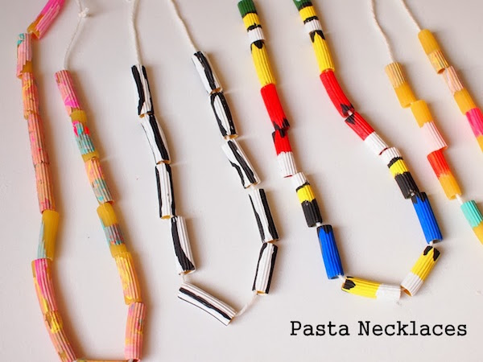  Expressive Arts & Design:  These are so easy to make. Using any pasta you have in the house. If not use paper and roll. You can make any pattern you like, colour. Remember to have fun. | RE: Talk about a time when we gave or received gifts.  How does it make us feel? Why do we give gifts? What would be a good gift to bring a new baby? Why?  -PSE - Think about special visitors who have come to your house or someone special you have visited. What did you have to do to get ready for them? | Understanding the World. Use google to research Kenya. This is where Handa’s surprise story is based on. What have you learned? Does Kenya look similar to where you live? What are the differnces? Similarities? Do we dress the same? Look the same? What do you notice? Use google earth to have a better in depth look.
 | Physical Development:  Ask your child to practise some handwriting and choose a letter from below. Write the letter across a piece of paper and then ask your child to write underneath on a line.  https://www.cursivewriting.org/arrow-alphabet-worksheets.html | Personal, Social and emotional development.  Watch story together. Be Kind.  https://www.youtube.com/watch?v=kAo4-2UzgPo  what does being kind mean? Is it had to sometimes show kindness when a friend is being mean to us? How do you feel when some one is kind to you? Discuss this with your child. | Physical Development:  Go for a walk, run, jog etc. try skipping. Friday afternoons are our PE times. We even put on music and dance! We use Justdance for kids on you tube. It is fantastic. You can type in a song and it even shows you the dance moves.

