Beginning with God –  Year B 6  Linking School, Parish and Home |  | 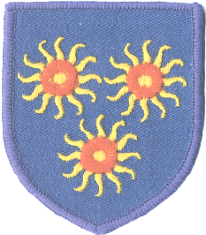
Religious Education
Key Idea:
This framework of learning is intended as the last in the liturgical year, Year B; the first in the academic year 2018/2019. As the title suggests the content of this resource is the nature of God. Both belief in the singular nature of God (Monotheism) and God as a Trinity are taught. Pupils will explore a variety of Biblical metaphors for God and learn about the Nicene Creed as a time in history when the nature of Jesus was considered and clarified.

Attitudes and Spiritual Dispositions
Spiritual Outcomes: It is hoped that pupils will develop:  - An appreciation of the nature of God as greater than what we can imagine or know  - A sense of the presence of God in their lives | - An openness to wondering about God as ‘three in one’.  - A sense of curiosity about God.
Activities to try at home
You are the first educator of your child in faith. Your child’s learning in religious education will be much greater if you and the school are engaged in talking about the same ideas and beliefs. This resource asks pupils to think about what God is like. Be open to the many metaphors they learn about and incorporate some into your family prayer.

An idea for prayer at home
Prayer Activity
Pray with your children:
God who is bigger than all we can imagine or say. Help us to see you in our world; in the beauty of the natural world, in the traditions of our Church, in the stories of Scripture and in the people around us. May we remember that, created in your image, we are like you and we show others what you are like. We ask this through Jesus who took on human to show us your great love, Amen.

