

St Edmund’s RC Primary School

Diocese of Westminster

Newsletter to Parents 25th January, 2019

|  |  |
| --- | --- |
| MCj00889620000[1]  **CLASS ASSEMBLIES**  1st February – Year 2  8th February – Year 1  15th February – Reception Class  Assembly starts at 10.10 a.m. in the Hall.  **After-School Clubs**  C:\Users\conorm\AppData\Local\Microsoft\Windows\INetCache\IE\ULC76SMY\images_(1)[1].jpg  After-school club places have now been allocated for the Spring Term. If your child has not been given a confirmation slip, they will be put on the waiting list for a place. Please note that when a club consists of two year groups there is the potential for 55-60 children applying for that particular club, when there may be just 12 places available. We attempt to make the allocation as fair as possible. Thank you for your understanding.  **Dates For Your Diaries**  March 4th & 5th – Parent conferences.  February 18th to 22nd – Half term holiday.  Monday, February 25th -School re-opens for the next half term. | **CLASS MASSES**  1st February – Year 4  8th February – Year 3  15th February – Year 6  Mass starts at 9.15 a.m. in church.  The Passage logo  A big **thank you** to all the children, who were able to raise £1,300 for The Passage as part of our Advent Appeal. Thank you to everybody for your generous sponsorships.  **C:\Users\conorm\AppData\Local\Microsoft\Windows\INetCache\IE\ULC76SMY\1-1232202763DIeJ[1].jpgKS2 Fruit**  Children in Key Stage 2 are allowed to bring in a piece of fruit or a vegetable to eat in school as a snack. Please do not bring anything that requires preparation, or anything that isn’t simply a piece of fruit or a vegetable. |

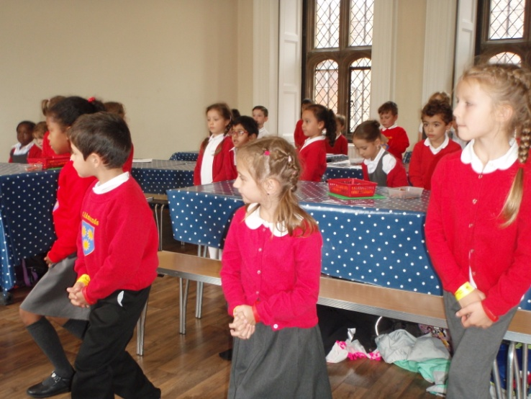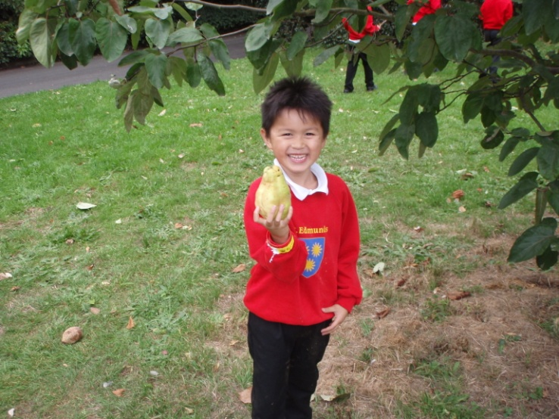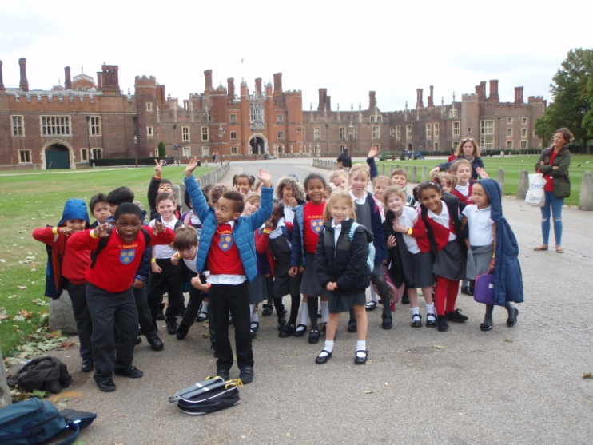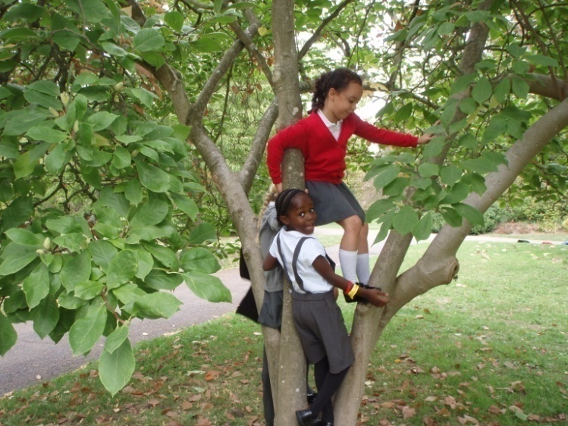

We are pretending to be Tudor ladies and gentlemen.

This is a Quince!

We’re relaxing in the grounds of a Tudor stately home.

**Year 2’s visit to Hampton Court Palace last term.**

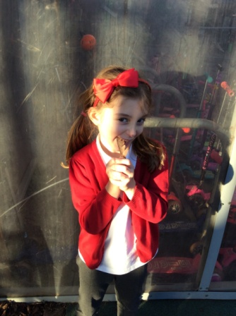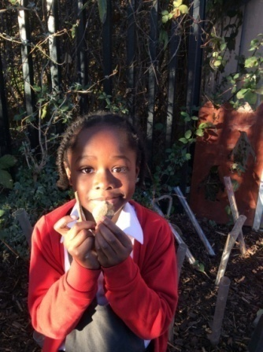

A leaf reminds me of God because leaves make oxygen which we need to live.

Stones and sticks remind me of God because they are strong.

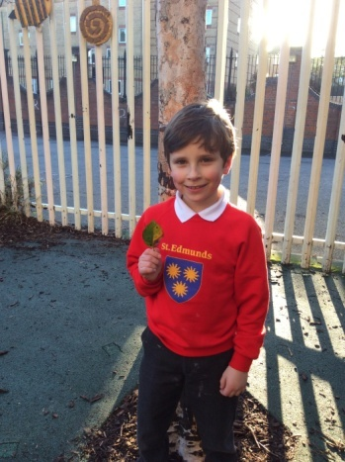

**Year 2 were looking at where we might find God in nature.**

A leaf reminds me of God because a leaf grows and I grow. Both created by God.