Being a Sacramental People - Year C  Linking St Edmund’s School, Parish and Home. |  | 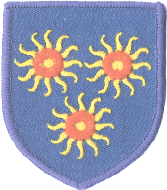 | 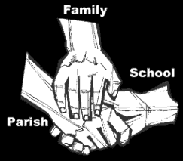
Religious Education: Spring A, 2019
Key Idea:
Having learned something of the nature of God we now ask where God is - and find out that God is with us in our world, bidden or not! Being sacramental means that we can know God in our everyday lives – the highs and lows, the joys and fears. There is nowhere that God is not! In this resource we look for God in the world and come to understand that knowing God in our everyday helps us to see how the Sacraments celebrate and express this. In this resource our need for healing, physical and social, in the Sacraments of Healing, is studied.
Attitudes and Spiritual Dispositions
Spiritual Outcomes: It is hoped that pupils will develop:  - An appreciation of God’s presence in the world  - A respect for relationships which bring God’s presence to us | - An attitude of openness to the Sacraments: words, actions and symbols  - A willingness to seek God in their own lives  - A recognition of the need for healing in the world.
Activities to try at home
You are the first educator of your child in faith. Your child’s learning in religious education will be much greater if you and the school are engaged in talking about the same ideas and beliefs.
- Healing is for body, mind and soul. It settles our fears, it takes away the sadness or our wrong-doing and it clears the way of obstacles which bind us.
- The best way to teach your children about healing is to be open and generous in your healing: your gift of it and your reception of it from those who love you.

An idea for prayer at home

Prayer Activity
Loving God,
At every moment of our lives you are present to us, God, in gentle compassion, in strengthening guidance and in and loving forgiveness. Help us to recognize you around us, especially in our actions and words so that our being in the world helps heal it of fear and hurt and doubt. We ask this through Jesus who taught us to love. Amen.

