Dear Parent of Y2 Children,
General Information about on line learning.
- On line learning is far from ideal, so please do the best you can with your child, to avoid them regressing, (going backwards).
- This timetable/format may be different from your child’s previous teacher.
- I’m assuming your child will have access to a PC, laptop or tablet. (A phone would probably not be suitable).
- I’m also assuming that you have access to a printer and that you can print worksheets, etc. (It is possible to do much of the work without printing the pages, but it would be easier for your child to learn, with the printed page in front of them.)
- I intend to call all of you by phone over the next week or so, to see how on line learning is progressing.
- Call the school and leave a message for me, if you want to talk to me.
- The lessons/activities for your child are aimed at an “average” Y2 child. If your child finds them difficult, then you may have to modify the activity to make it easier, or give them extra support. Don’t do it all for your child though; if you do that, your child will not be learning. Sometimes I am able to give you alternative easier, activities.
- I will welcome feedback, comments and suggestions about how I can make it easier for your child to learn at home.
- Generally speaking, I will set 1 assignment a week. This will be a longer piece of writing, which I will expect to be uploaded to Google Classroom. I will therefore be able to see the progress your child is making and be able to suggest improvements. Google Classroom should be up and running by Friday 8th January.
Remember:
- For your child, the important thing every weekday is to;
- Read every day. Try Oxford Owl e books https://home.oxfordowl.co.uk/books/free-ebooks/
- Do some maths;
3. Do some writing.
General information about the work this week. (6-1-2021)
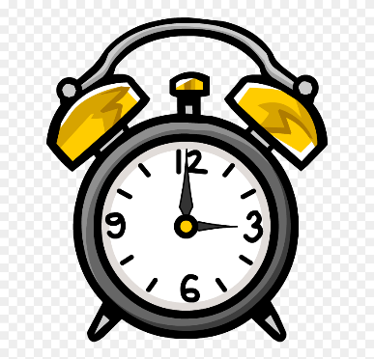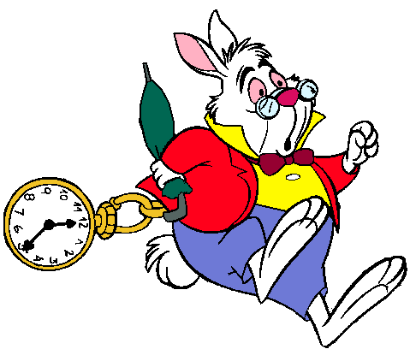

- English/RE is initially looking at the story of the 3 Wise Men, as 6th January is the feast of the Epiphany.
- The assignment on Friday is to write a story about following a rabbit.
- In Maths, we will be looking at telling the time, both analogue time, (8 o’ clock) and digital time, (8:00), using the Discovery Education website and some You Tube videos. You will need a split pin, (butterfly clip) and some card, for your child to make their own clock.
- There is 1 assignment for your child to complete. (The Friday English lesson, writing the story.)
- This week, the timetable will be loaded onto the school website, but from next week onwards, you will have to access the next weekly timetable through Google Classroom.
- Below is a timetable for the week beginning Wednesday, 6th January, 2021. (Spring A, Week 1)
- There are 2 lessons a day; a maths lesson and a lesson involving reading/writing - English. This may be taught through; RE, History, Geography, Science, etc.

Year 2: Week beginning Wednesday 6th January 2021. (Spring A; Week 1)
Wednesday 6th June
First Lesson  Maths: Time | Second Lesson  English/Geography/Science/RE
Learning Intentions (L.I):  Recite the multiples of 5  Making a paper clock.  Setting the clock to hour times.  -Get your child to count in 5’s up to 60 and the back down to 0.  -If they find this difficult, get your child to colour the multiples of 5 on a 100 square first. (see the link below of you want to print a 100 square)  https://nrich.maths.org/content/id/8506/1-100_NumberGrid.pdf  -If your child finds counting in 5’s too easy, get them to answer, for example 5x9, and other answers in the 5x tables, rapidly.  -Make a clock using a split pin. The following You Tube video could be helpful. Obviously it does not have to be exactly like the clock in the video, as long as the hands on the clock are capable of moving. If you do not have a paper plate, then you could get your child to cut out a circle from some card. (cereal packet?).  https://www.youtube.com/watch?v=FdsMxw62v3Q  -Get your child to watch the You Tube video (What’s the time Mr Wolf?)  https://www.youtube.com/watch?v=wnpAmWrhT6o  -Play the video a 2nd time and get your child to make the times shown in the video on their home made clock.  -Get your child to write the equivalent digital times with the analogue time, for example; 7 o clock = 7:00 | RE/English: The 3 Wise Men/Kings visit Jesus.  -Today, on the 6th January, Christians celebrate the visit of the 3 wise men to the Baby Jesus.  -Tell your child that in some countries, Christmas presents are exchanged on this day and not 25th December. Ask your child if they would prefer this, or not!  -Get your child to watch the video.  https://www.youtube.com/watch?v=22SMUUMsx0o  -If your child is able to, get your child to read the transcript of the story, (below this time table), or if they find it difficult, you could play the video, whilst your child follows the words. You may need to explain new/difficult vocabulary to your child as this will be difficult text for most Y2 children. The aim is that the video will help them understand it.  -Repeat if required.  -Get your child to answer the comprehension questions about the visit of the 3 wise men. Your child should write the answers in their exercise book.  -If it helps, get your child to answer the questions verbally first. They can refer back to the transcript, or the video as often as they like, to find the answers.  -Ensure that the questions are answered in full sentences, for example:  Question: Where was Jesus born?  Answer: Jesus was born in Bethlehem.  -If your child finds the level of the text too difficult, then get them to sequence the 4 pictures of the visit correctly and to write a sentence underneath each one, explaining what is happening in each picture.

Thursday 7th January
First Lesson  Maths: Time | Second Lesson  English/Geography/Science/RE
Learning Intention (L.I): Telling the time; on the hour and half past the hour.  -Log in to the Discovery Education website  https://www.discoveryeducation.co.uk/  - Click on the padlock icon (top right) and login under “espresso”  - Log in using; Username: student20648; Password: edmund  - Go into Key Stage 1/Maths/Scroll down to Time  - Go to Videos (top left) and choose; Hours and half hours: finding the time. Get your child to watch this video.  - Go to; Activities, (top left.) Click on the activity; Telling the time (hour/ half hour) and get your child to do this online activity.  - Go to; Printable resources (top left), print; Telling the time - o’ clock and half past, and get your child to both tell/write the time and draw in the hands of the clock on this worksheet.  - An addition optional worksheet is below (Telling time on the hour)  https://www.mathworksheets4kids.com/worksheets/1st-grade/time/telling-hourly-increment-1.pdf | Science/Geography: Identifying conjunctions and using them (Joining words)  -Get your child to re-read the text from Wednesday, about the visit of the 3 Wise Men.  -Remind your child what a conjunction is and what is its’ function. (and, then, so, as, by, where, who, because, but since from, for, which, etc). (Conjunctions join sentences together and you can use them to extend a sentence).  -We have studied conjunctions before, in Y2 before Xmas.  -Print out the text and get your child to underline the conjunctions. If your child finds this difficult, provide a list of the conjunctions in front of them, so that they can refer to the list.  -There is a copy of the 3 wise men story with the conjunctions highlighted, below this timetable, if you need answers.  -At the end of this timetable is a writing task. Your child should copy and then extend each sentence, using a conjunction;  -For example: I saw a white rabbit but I thought I was dreaming. Your child will have to use their own imagination to extend the sentences.

Friday 8th January
First Lesson  Maths: Time | Second Lesson  English/Geography/Science/RE
Learning Intention (L.I):  -Tell the time on the hour and half past.  -Know the digital equivalents for these times.  -Record the activity from the video in a sentence.  -Log in to the Discovery Education website  https://www.discoveryeducation.co.uk/  - Choose “espresso”  - Log in using; Username: student20648; Password: Edmund  - Go into Key Stage 1/Maths/Time  - Go to Videos (top left) and choose; Day on the farm (part 1). Get your child to watch this video.  - Get your child to create a table with 3 columns.  - Get your child to verbally tell you what the times are.  Analogue time Digital Time What happened?  Half past 7 7:30am Getting food ready for the goats and llamas.  - Get your child to fill in the table like the example above with the other times and activities.  - Your child could also make the time, using their own clock that they made on Wednesday.  - You will need to explain what “am” means. (morning, Latin for: anti meridiem, before the sun crosses the meridian line, before midday)  - If you have time, exactly the same activity could be done using the video; Day on the farm (part 2). You will need to explain what pm means. | Learning Intention: Writing a story  -Watch the video of Alice following a rabbit from, “Alice in Wonderland”  https://www.youtube.com/watch?v=XMVwQcjn3NY  -In the Wednesday lesson, the Wise Men followed a star. In this lesson, someone follows a white rabbit.  -Tell your child to imagine that they are in the; park, playground, farm, street, etc. They see a white rabbit, who seems to be late, so they try to follow it. (Maybe your child can tell the rabbit the time?)  -Write a story about what happened and what they find when they meet up with the rabbit.  -Your child will have to use their imagination to write this story.  -Your child can use some of the sentences they created yesterday with conjunctions and use them in their story.  -I will assess the story using the following criteria.  - Make sense.  - Use capital letters and full stops.  - Include events (Things that happen)  - Include a problem.  - Use some conjunctions (when, if, but, so, because, if, since, while, that, which….)  - Include some different sentence starters. (Not all sentences should begin with “I…or then.”)  - Have letters which are the correct height.  - Include an exclamation mark!  - Include a question with a question mark. (?)  - Adjectives.  -Upload this story that your child has written onto Google Classroom. The best way is to take a photo. DO NOT get your child to type the story. At this age they still need to develop their fine motor/handwriting skills.
The Visit of the 3 Wise Men (Transcript of the video)
https://www.youtube.com/watch?v=22SMUUMsx0o
Jesus was born in Bethlehem, in a region where the evil King Herod ruled. About the time of Jesus’ birth, some wise men from the East arrived in Jerusalem, asking King Herod, “Where is the new born King of the Jews? We saw his star as it rose and we have come to worship him.”
King Herod was angered by what he had heard. A King other than himself, in his own land? Herod called a meeting of the leading priests and teachers of religious law and asked, “Where is the Messiah supposed to be born?”
“In Bethlehem in Judea, for this is what the prophet wrote.”
“You Bethlehem are one of the smallest town in Judea, but from you will come one who will rule Israel. This comes from very old times, from days long ago.”
Then King Herod called the Wise Men back in for a private meeting. He told the Wise Men, “Go to Bethlehem and search carefully for the child, and when you find him, come back and tell me so that I can worship him too. “
After listening to the King, the Wise men left to follow the star. They arrived at the place where Jesus was and going into the house, they found the promised child and his mother Mary. They gave him offerings of; gold, frankincense and myrrh and were so overjoyed at the fulfilment of God’s promise, they bowed before Jesus and worshiped him. That night in a dream, the Wise Men were warned about returning to Herod as he was plotting to kill Jesus. When they awoke, they departed and travelled back to their own country a different way.
Comprehension Questions: The Visit of the 3 Wise Men
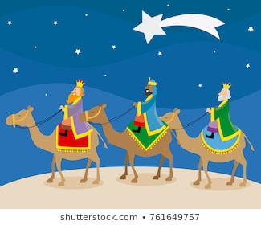
- Where was Jesus born?
- Who ruled in the region where Jesus was born?
- How did King Herod feel when the wise men told him about the birth of Jesus?
- Why did King Herod call the Wise men back for a private meeting?
- What gifts did the Wise Men give Jesus?
- Why did the Wise Men not go back to Herod and tell him about Jesus?

Sequence The Pictures of the Visit of the 3 Wise Men
Print, get your child to cut them out, sequence in the correct order and stick in your exercise book.
Write a sentence under each one, saying what is happening.
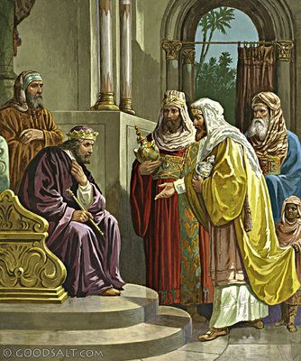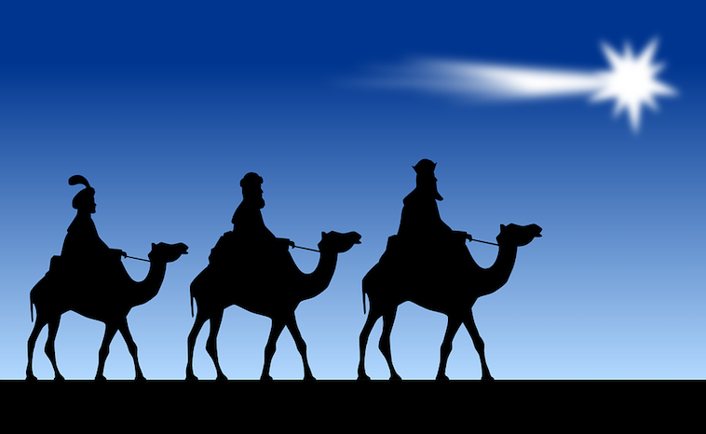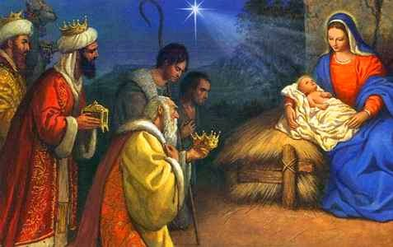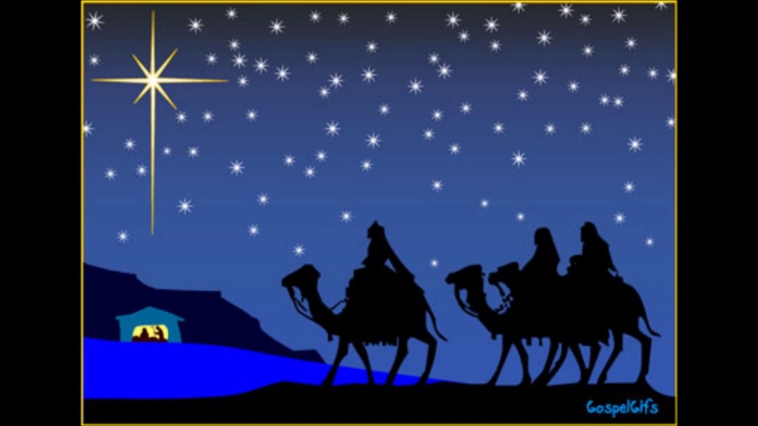

The Visit of the 3 Wise Men with Conjunctions highlighted.
Jesus was born in Bethlehem, in a region where the evil King Herod ruled. About the time of Jesus’ birth, some wise men from the East arrived in Jerusalem, asking King Herod, “Where is the new born King of the Jews? We saw his star as it rose and we have come to worship him.”
King Herod was angered by what he had heard. A King other than himself, in his own land? Herod called a meeting of the leading priests and teachers of religious law and asked, “Where is the Messiah supposed to be born?”
“In Bethlehem in Judea, for this is what the prophet wrote.”
“You Bethlehem are one of the smallest town in Judea, but from you will come one who will rule Israel. This comes from very old times, from days long ago.
Then King Herod called the Wise Men back in for a private meeting. He told the Wise Men, “Go to Bethlehem and search carefully for the child, and when you find him, come back and tell me so that I can worship him too. “
After listening to the King, the Wise men left to follow the star. They arrived at the place where Jesus was and going into the house, they found the promised child and his mother Mary. They gave him offerings of; gold, frankincense and myrrh and were so overjoyed at the fulfilment of God’s promise, they bowed before Jesus and worshiped him. That night in a dream, the Wise Men were warned about returning to Herod as he was plotting to kill Jesus. When they awoke, they departed and travelled back to their own country a different way.
Extend these sentences using conjunctions
- I saw a white rabbit………………..
- The rabbit went down a hole………………..
- The rabbit was late………………………
- I reached out to stroke it…………….
- There was a carrot in my pocket from story time……………..
- I know rabbits like carrots…………………

