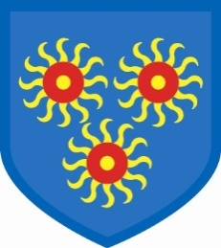St Edmund’s Catholic Primary School

Diocese of Westminster

[www.st-edmunds-school.org](http://www.st-edmunds.towerhamlets.sch.uk)

**Follow us on twitter @stedmundsschoo1**

Parents Newsletter 31st March 2021

**Lenten Appeal**



We would like to say a huge thank you for all of your kind donations to St Luke’s and St Edmund’s foodbanks. We know that these are all gratefully received.

**INSET Day**



This will take place on Monday, 19th April. The first day back for the children will be **Tuesday, 20th April.**

**Easter Message**

As Easter approaches we are aware that the children have not had the opportunity to spend time in Church as we normally do at this time of year. Whilst we continue to teach the meaning of the Easter message, the children will benefit from further reflection and discussion around this most important of celebrations.

**Easter Holiday**

We would like to wish all of our families a safe and happy Easter holiday. We look forward to welcoming the children back on Tuesday, 20th April.

**Parking**



We have been contacted by some of our neighbours about parents parking during drop-off and pick-up times.  Many of you are parking illegally and some are parking on the pavements, particularly facing the school gates.  This makes already narrow pavements even narrower, which makes it even harder to follow government instructions to maintain distance from each other.  There is no need for any of you to park so close to the school.  There is much safer parking down the various side streets leading into Westferry Road, which will only add a minute or two to your journey.  Doing this will also reduce some of the air pollution around the school.  Please do consider our neighbours when parking.

**Local Elections**

Our school will be used as a polling station on **Thursday, 6th May** for the local elections**.** Therefore, the school will be closed to pupils on this day.



### Preparation for Easter

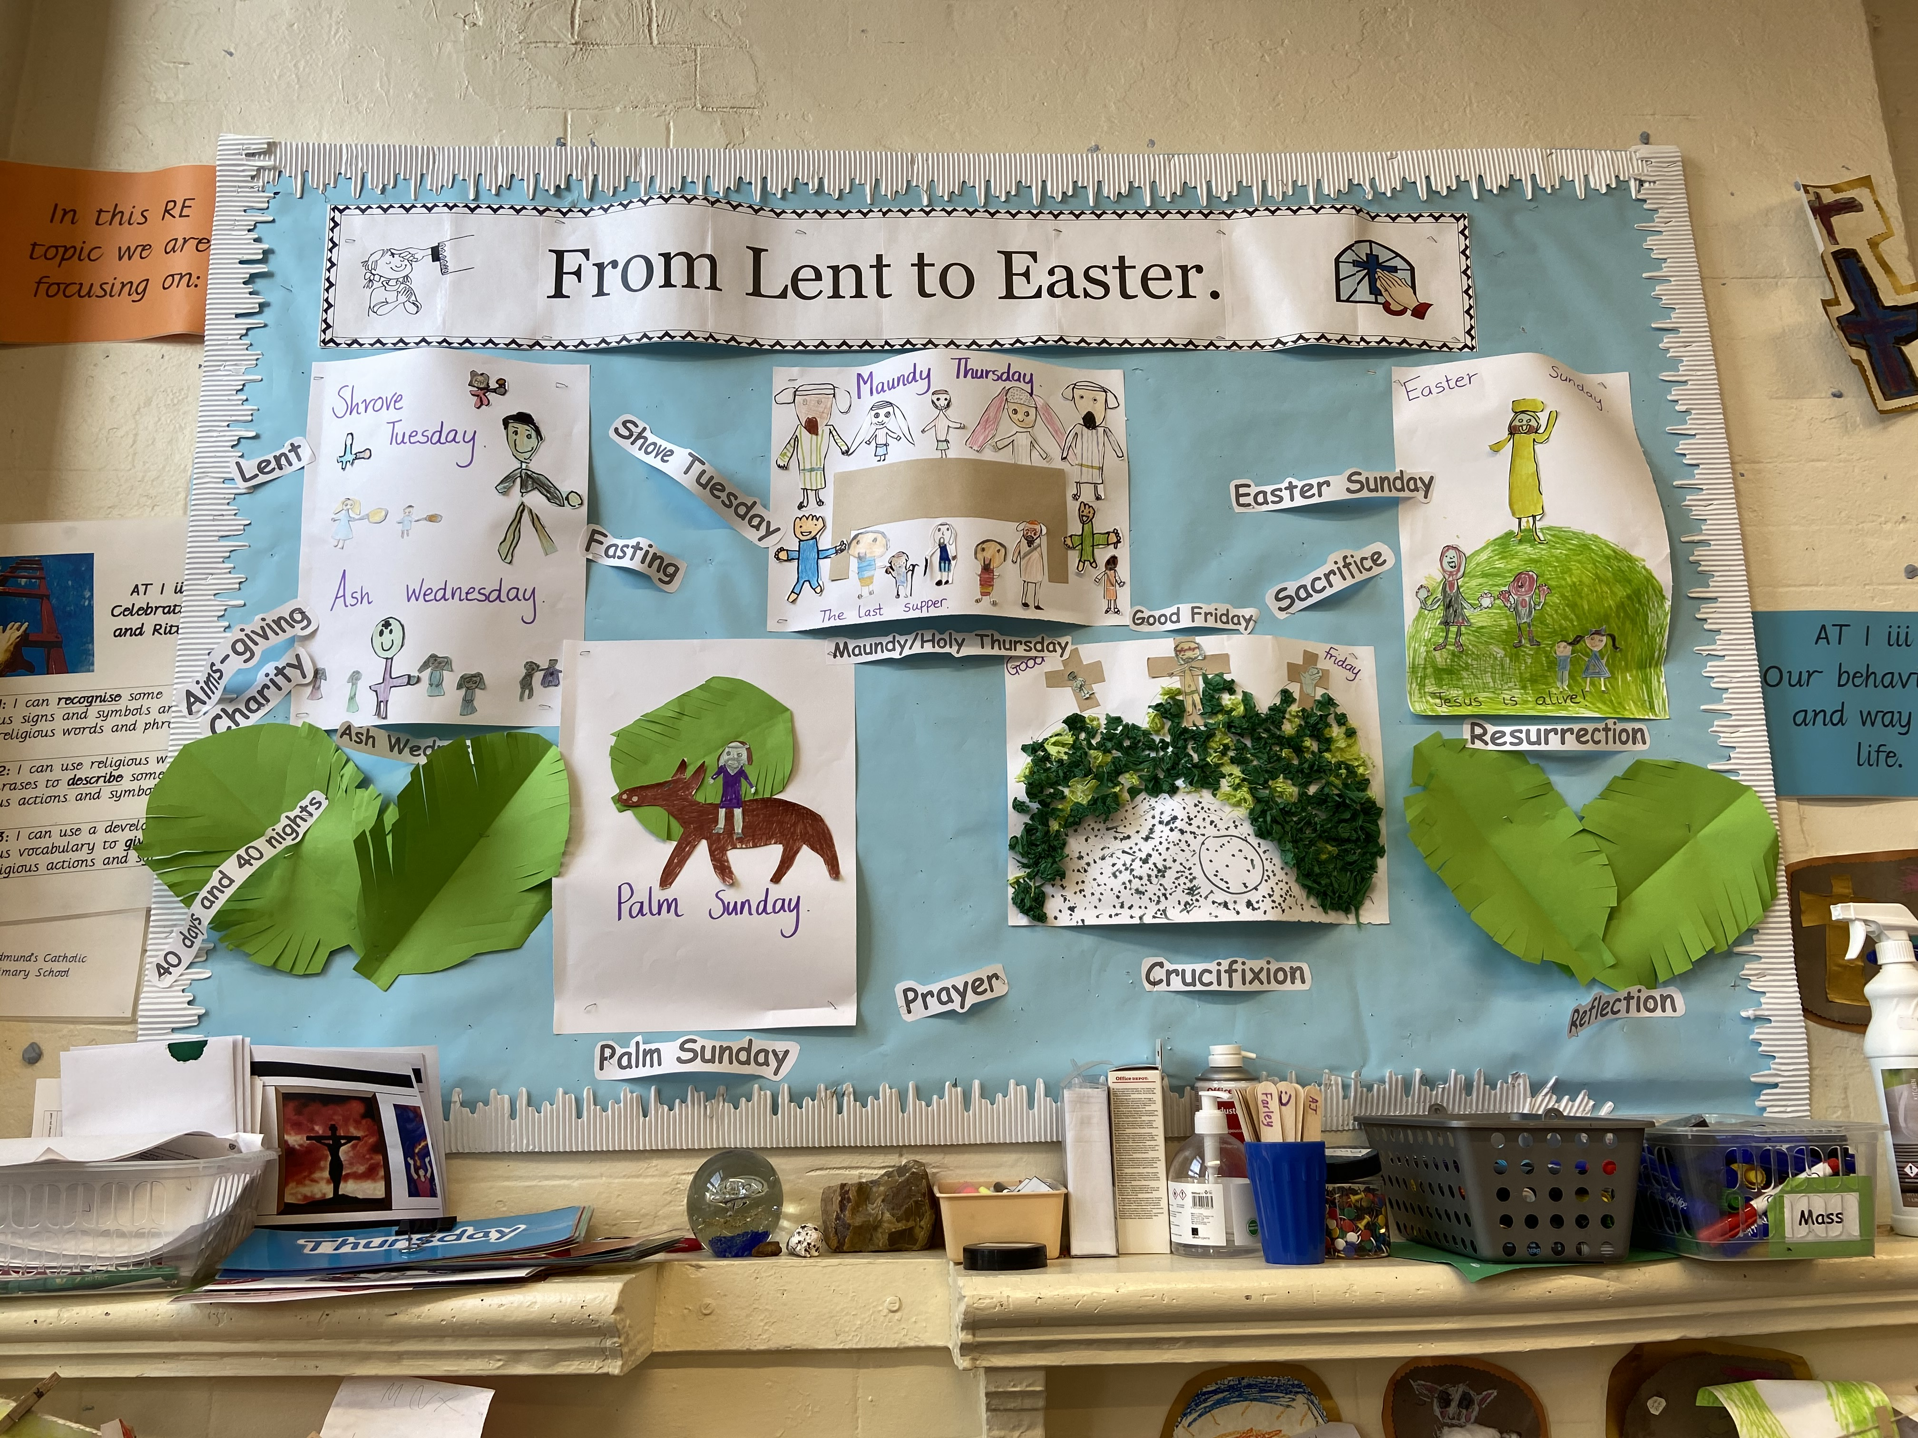

.

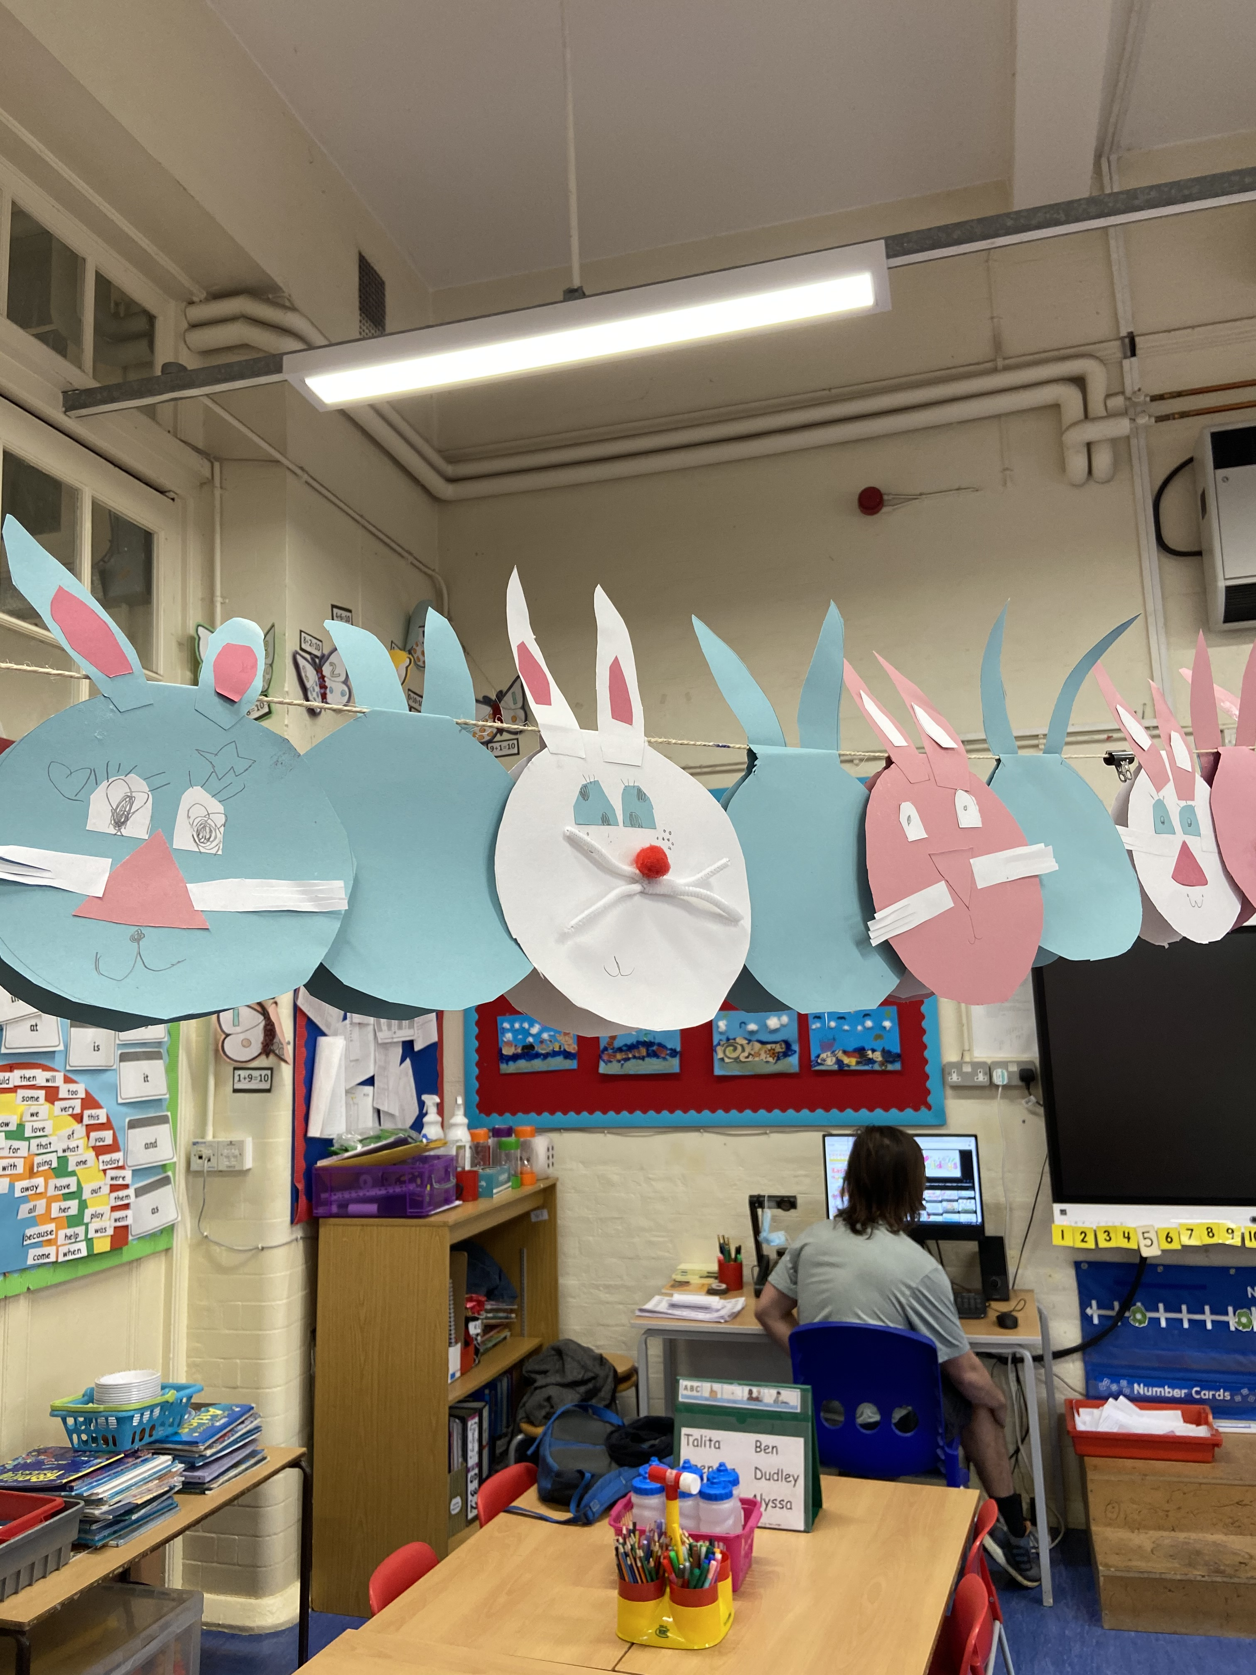

In school, we have been busy getting ready for Easter. We have been studying the Easter story and making Easter cards and crafts.

