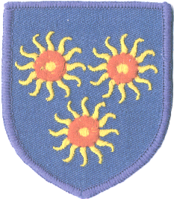
St Edmund’s Catholic Primary School
Diocese of Westminster

Newsletter to Parents 23rd February 2018

Class Assemblies



Year 4 – 2/3/18
Year 5 – 9/3/18
Year 6 – 16/3/18
Reception – 23/3/18
Assemblies start at 10:10 a.m.
Parent Conferences



Parent Conferences will be held next week. Please see the sign-up sheets on the glass doors to select a time that best suits you!
We strongly encourage parents to bring their child along with them.

World Book Day



We are celebrating World Book Day on Thursday, 1st March. Children are encouraged to come dressed as their favourite book character, for a donation of £1 which will go towards our
Lenten Appeal.

Book Fair &
World Book Day Vouchers



All children will be given a £1 World Book Day Voucher. Keep them safe so that you can use them at our
Book Fair in the hall each afternoon,
on 22nd, 23rd, 26th and 27th March 2018.

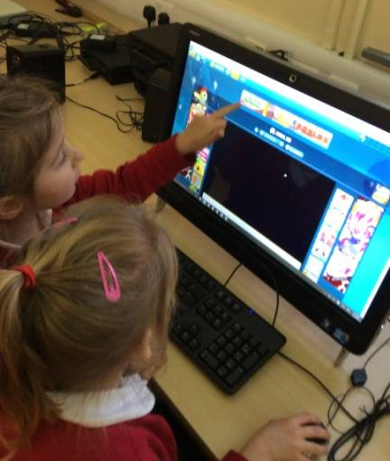
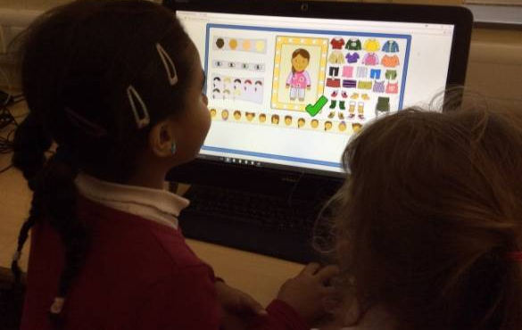
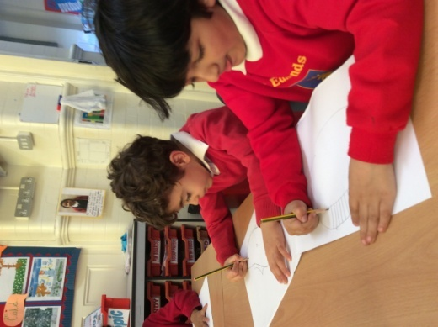
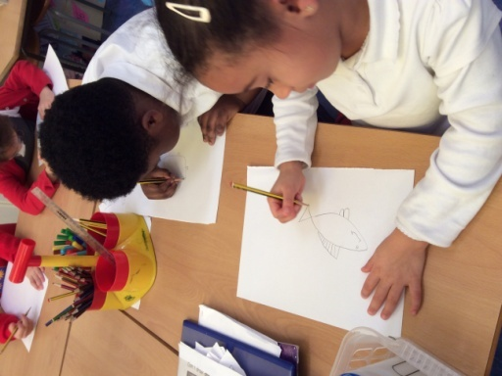
Fish Art! We have been following instructions to draw our own fish!
We have been investigating the different types of games. We have looked at ‘apps’ and searched websites using a search engine.
We are going to design our very own sea creature games!

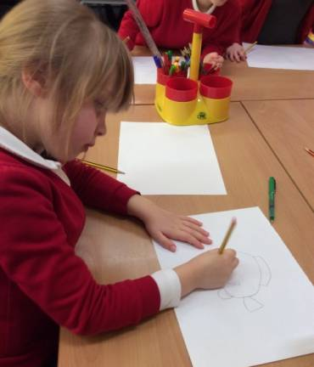


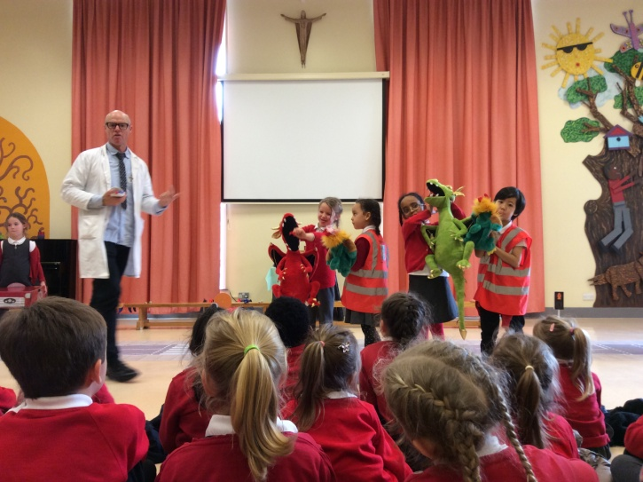
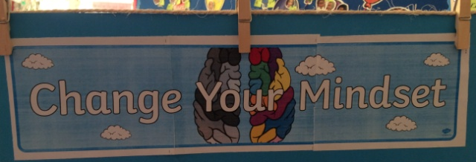
We are learning about road safety in Year One and Two. It is very important that we are able to stop and look, before crossing the road.
We are active and confident learners!

In Year One, we have been trying to become more independent when learning! We have been working on remembering instructions, helping and reminding our friends too!

