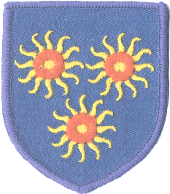

St Edmund’s RC Primary School
Diocese of Westminster
www.st-edmunds.towerhamlets.sch.uk
Follow us on twitter at; StEdmundsSchoo1

Newsletter to Parents
13th November, 2018

ST EDMUND‘S DAY  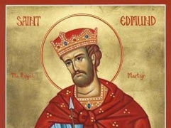  The feast day of St Edmund of Abingdon, the patron saint of our school, is on Friday 16th November.  A mass will be held in the church at 9.15am. All are welcome.  This day will be a non-uniform day and children can wear their own clothes. We will be having a party in the afternoon.  CHRISTMAS DISCO  Friday, 7th December is the Christmas disco! School Councillors will be selling the tickets in class. Tickets cost £2  Nursery, Reception, Y1 & Y2: 4.30-6pm  Y3,Y4,Y5,Y6: 6.15-8.15pm  . | AFTER SCHOOL CLUBS  The last after school club this term will be on Thursday, 29th November. There are no after school clubs in December. The after school care sessions will still continue until the end of term.  CLASS ASSEMBLY DATES  23rd November- Year 1  30th November-Year 5  7th December-Year 6  Assembly starts at 10.10am

