Weekly plan for Caterpillars (11^{h} –15th May)
Dear parents/Carers,
I have tried to design this timetable to make it as fun as possible for you and your child. I have put in examples to guide you, however, please feel free to use your imagination and go for it! Here is a rough timetable for you to use with your child if you have the time. We understand the pressures you are under and this is optional – it is just to support you as you spend time with your child. It is also important to remember that your child needs lots of brain breaks and opportunities for play (we know you know this)– role play, gardening (if this is possible), outside exercise (again, we know the limits), baking, drawing, painting etc..Also, obviously feel free to do these activities when they suit you – you do not have to stick to the times on the timetable.
 | 9am – 9.20am  Literacy | 10am – 10.15am  Phonics | 11am- 11.20am  Maths | 1.30-1.45pm | 2.30pm – 3pm
Monday | New topic, Minibeasts. Follow the link for the book, Superworm. https://www.youtube.com/watch?v=7Jnk3XApKBg What a fantastic story. Talk to your child after listening to the story and see if they can retell some of the story back to you.  -Practise name writing each day. Remember to encourage your child to hold the pencil correctly. | https://www.youtube.com/watch?v=h0Kp_J9kvNM  This is a phonics phase one listening game. Let your child listen to the sound and pause, ask them to guess which sound it is then press play. Are they correct? | 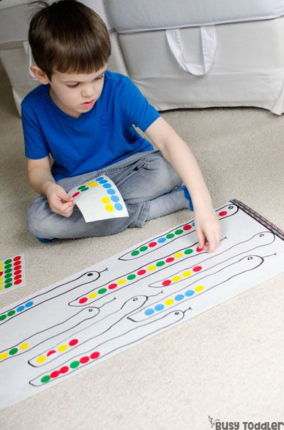  - Introducing patterns. Draw a worm on a piece of paper. Use stickers, coloured paper or coloured pencils. Whatever is available. Can you make a pattern?  e.g: red, yellow, red, yellow. Or even blue, red, yellow, blue, red, yellow. | Today while out for your walk I need you to look for worms, lots of worms… ! Tomorrow you are going to make a wormery. Did you know that worms like to eat banana skins, coffee and nettles and comfy leaves? You can investigate why. | -Have a bit of quiet time together if possible. Read a story and share a snack or two together.  Story time is especially important for your child.
Tuesday | -Practise name writing in the exercise book sent home. Write their name on a piece of paper first and ask them to copy it. Write with highlighter pen if they want to copy over a model.  -We have been reading “Superworm”. What is a Superworm? This is where you need to do more investigating. Draw a picture of Superworm and then write why all the other creatures liked Superworm. What made him Super? | https://www.youtube.com/watch?v=4GhEGU0wUc0  Repeat how you played the game yesterday. | - Cut out 2D (flat) shapes for your child. Triangle, rectangle, square, circle, pentagon and hexagon. Ask your child to name the shapes. Use the shapes to make a Superworm. Using shapes is essential for memory recall. | 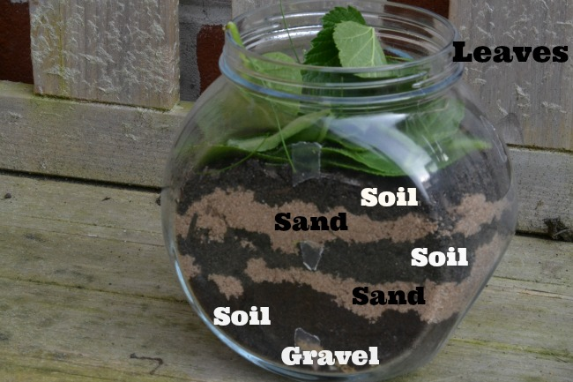  Make a home made wormery.  Parent’s don’t freak out! You and your child are going to get messy and make your own wormery. You can use plastic bottles for example - the end result will be the same. | Watch Jesse the minibeast teacher on the link teaching you all about worms.  https://www.youtube.com/watch?v=l-zc_1vjLnI
Wednesday | 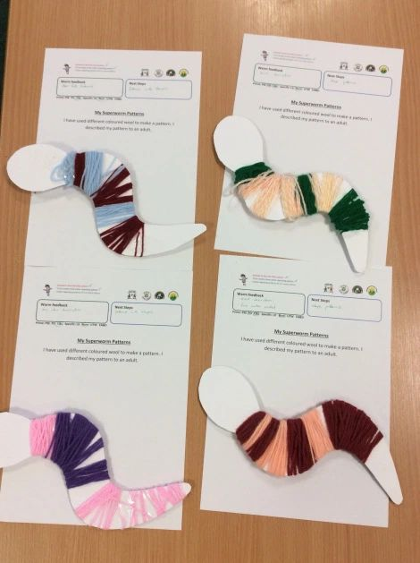  -  Parents could you cut out a long Superworm? Give your child some string and ask them to decorate it. On Monday we looked at patterns. You may want to decorate your worm using a pattern. If you have no string use strips of paper, adapt to suit your needs. This is a great activity for fine motor skills. | https://www.youtube.com/watch?v=3JA2yR8ZMzc  Dear Zoo, animal sounds. Again let your child listen to the sound and pause, guess the sound and press play. This is fun to play with siblings too! | 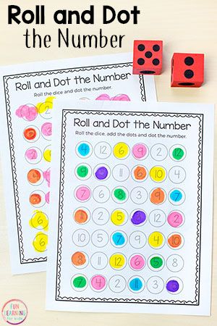  Parent to write numbers all over a paper from 1-10. Or 11-20. Roll 2 dice and ask your child to find the correct number and colour in. Have fun play together. Make each family member a card and the winner is the one with all the numbers coloured in. | -Baking. Why don’t you make some Superworm bread? No yeast!!  Recipe. 2 cups all purpose flour, ¾ baking soda, ½ teaspoon salt, 1 cup buttermilk or any milk, 3tablespoons of butter. Whisk flour, baking soda and salt. Add milk, melted butter and mix. Flour table and knead the dough. Then make long Superworm shapes and bake for 30 mins. Other recipes are online. | - Take all your cushions, pillows and make a comfy space. Include your child’s favourite toys. Read together.
Thursday | - Look at the books your child has at home. Ask them to choose a book to look and read to them. Ask them questions about the story. Use the Oxford Owl books online if you have read all your books at home.  Look at the parent curriculum map for stories we are reading this term. | https://www.youtube.com/watch?v=3ACKMwCvhkY  Learn the Superworm rhyming song. In phonics rhyming is essential when teaching the children. | -Sing some number songs with your children.  You tube has a variety of number songs. Sing number songs each day.  Make up a number song, have fun.and include homemade instruments if you choose. Just go for it! | From Easter to Pentecost-  We can be ‘Spirit People’ filled with kind messages for others. Talk about how we can use what we say to encourage each other:  Well done; that is lovely work; I like your….; could you show someone how to…  Recall our Lenten appeal and look at the charity Catholic Children’s Society. What has our Kindness done for others? | -Have a bit of quiet time together if possible. Read a story and share a snack together.
Friday | -Practise name writing in book.  -In Superworm there is a bad Wizard Lizard. What makes him so bad? Why was he called a Wizard? Did he have special powers? If yes, what were they? Why did he want Superworm? Draw the Wizard Lizard. Then write what you think about him. I know some of you will like him and he will be your favourite character. That is cool.  NB- ask them to use THEIR writing – which will be a mixture of mark making and letters – then to draw a picture. | - Sing Nursery rhymes with your child. There are hundreds of rhymes to learn. Look online or use the free book service to find nursery rhymes. | -Write numbers clearly from 1-10. Can your child trace over the numbers? Can your child write the number underneath? As your child is writing the numbers remember to always ask what number they are writing. Can they write 11-20 for a challenge?  Go for it!! | -Use your schoolbook to draw one of the minibeasts from Superworm. Find out some facts about them. Can you tell your adult what you have learned? Write underneath your drawing what you have learned. This is a great activity for parents to get involved in. Use the free books online to research or the internet. Children need to learn how we find out information. | Follow the link and watch  The Gingerbread Man.  https://www.youtube.com/watch?v=pckuS--UlV4  This is not part of the topic, however, your child loves this story and always laughs at the voices and music. Enjoy together.

