A Virtuous Life - Year C  Linking St Edmund’s School, Parish and Home |  |  | 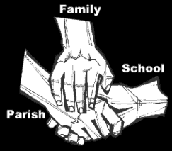
Religious Education; Summer B, 2019
Key Idea:
This resource completes study of the Gospel of Luke by examining one of his most favoured texts, the Good Samaritan, and by relating the actions of the Samaritan to the cardinal virtues. The resource concludes with an investigation of a Saint. Some classes will be looking St John Southworth and by asking the eternal question, who is my neighbour?
Attitudes and Spiritual Dispositions
Spiritual Outcomes: It is hoped that pupils will develop:  - A sense of a virtuous person  - An openness to the virtues that are presented | - A willingness to try and live these virtues
Activities to try at home
You are the first educator of your child in faith. Your child’s learning in religious education will be much greater if you and the school are engaged in talking about the same ideas and beliefs.
- The virtues of prudence, justice, courage and restraint sound as if they have come from another era! However, the notion that we should think before we act, and consider before we speak is one that has real relevance in today’s world. Talk to your children about the kind of people you want them to be: and the need to practice being thoughtful about, and perhaps even containing, our behaviours.

An idea for prayer at home
Prayer Activity
Lord Jesus, you challenged the lawyer to consider the Samaritan as someone who loved his neighbor, in a time when they were outcast and condemned. Help us to see those who we find hard to like as among those we are invited to love and care for. Help us to learn to think before we act or speak and to act with courage in living your words. We ask this in your name, Amen.

