The Year of Faith  Linking St Edmund’s School, Parish and Home |  | 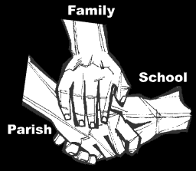
Religious Education : Spring B: 2019
Key Idea: Lent and the Passion of Jesus.
Students will explore the season of Lent as a time of thoughtfulness (penance), prayer and generosity (almsgiving). The season of Lent ends on Holy Thursday with the beginning of Holy Week. This unit looks only at the passion of Jesus, not the resurrection. The Resurrection, post Resurrection experiences and Pentecost are covered in the next topic.
Unit Content
This unit develops pupil understanding of the Stations of the Cross as a devotional practise common in Lent, and of the key events in the Passion of Jesus. It draws on the Gospel of Luke.
Attitudes and Spiritual Dispositions
It is hoped that pupils will develop:
- A sense of reflection and prayer
- An openness to the presence of God in the Eucharist
- A willingness to be part of Lent and Easter celebrations

Activities to try at home
You are the first educator of your child in faith. Your child’s learning in religious education will be much higher if you and the school are engaged in talking about the same ideas and beliefs. Help your child by trying one or more of these activities while this unit is being taught:
- Lent invites us to think about others. As a family pledge to do something special for another person this Lent.
- Eating together is a wonderful way of celebrating your family. Make a special point of sharing a meal together. Say the grace below.
An idea for prayer at home
Prayer Activity
Pray with your children at meals.
Loving God, in Jesus you often sat at the table with your friends and told stories to remind them of how much God loved them. May the stories we tell at this table remind us that we too are loved by you, and be a sign of the love and care we have for one another this Lent.
Amen

