Hail Holy Queen
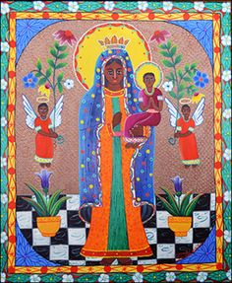
Hail, Holy Queen, Mother of Mercy,
Our Life, our sweetness and our hope!
To you do we cry, poor banished children of Eve;
To you do we send up our sighs, mourning and weeping in this vale of tears.
Turn then, most gracious Advocate, your eyes of mercy towards us;
And after this our exile, show unto us the blessed fruit of your womb, Jesus.
O clement, O loving, O sweet Virgin Mary.

