Weekly plan for Caterpillars (18th –22nd May)
Dear parents/Carers,
I have tried to design this timetable to make it as fun as possible for you and your child. I have put in examples to guide you, however, please feel free to use your imagination and go for it! Here is a rough timetable for you to use with your child if you have the time. We understand the pressures you are under and this is optional – it is just to support you as you spend time with your child. It is also important to remember that your child needs lots of brain breaks and opportunities for play (we know you know this)– role play, gardening (if this is possible), outside exercise (again, we know the limits), baking, drawing, painting etc.. Also, obviously feel free to do these activities when they suit you – you do not have to stick to the times on the timetable.
 | 9am – 9.20am  Literacy | 10am – 10.15am  Phonics | 11am- 11.20am  Math’s | 1.30-1.45pm | 2.30pm – 3pm
Monday | New topic, Minibeasts. Follow the link for the book “What the Ladybird Heard”- https://www.youtube.com/results?search_query=what+the+ladybird+heard+story  What was the story about?  Can you remember all the animals from the story? What was the ladybird doing throughout the book?  Encourage your child to retell the story.  Practise name writing each day. Remember to encourage your child to hold the pencil correctly. | As a family play Chinese whispers. Tell your child something in tehri ear, tell them to pass it on and keep going till all the family have heard. Now ask each person what they were told. You maybe surprised how the message has changed! | 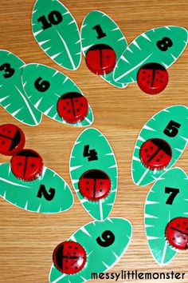  This is a ladybird maths game. You can make these with your child. You can go higher - 11-20. Ask your child to find you a number, you can also roll a dice and put a cube on the correct number or make a number line with the leaves. | Follow the link to make a ladybird catcher.  https://www.pinterest.co.uk/pin/550565123199786648/  While out for your daily walk see if you can catch a ladybird. It’s so easy to make a ladybird catcher, you just need an empty plastic bottle and a stick. Happy hunting! | -Have a bit of quiet time together if possible. Read a story and share a snack or two together.  Story time is especially important for your child.
Tuesday | -Practise name writing in the exercise book sent home. Write their name on a piece of paper first and ask them to copy it. Write with highlighter pen if they want to copy over a model.  Lanky Len and Hefty Hugh were bad in the story. What made them bad? Ask your child to make a poster to help the police catch them. Ask your child to first draw a picture. Then encourage them to write under their picture. See if they can describe the burglars. Colour hair, eyes, tall, short, fat, thin etc. | Play I spy. You can also play this game on your daily walk. | Give your child a plain piece of paper and ask them to draw a map. Look at the map in what the ladybird heard. Ask your child what they can see? Let your child draw everything they see. You can do this on your walk together. You can even count how many steps to each object drawn. We have made lots of maps in school this way, you will be amazed how much detail your child can draw. | 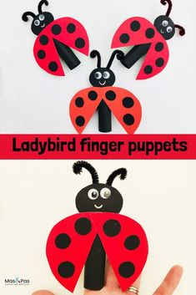  These finger puppets are easy to make and your child will have lots of fun. Use the paper from their exercise books and use their colours too. | Watch Jesse the minibeast teacher on the link teaching you all about ladybirds.  https://www.youtube.com/watch?v=nl7KqpqoN9o
Wednesday | Watch the short animated version of “What The Ladybird Heard.”  https://www.youtube.com/watch?v=-gRfCIUKDuY  In the story Hefty Hugh and Lanky Len must take a particular path through the farm. Can you draw each animal they must pass and write the name underneath too? | Look at previous phonics activities from previous weeks. In phonics phase one repetition is so important, the more we repeat and practise the better your child will be with phonics. | 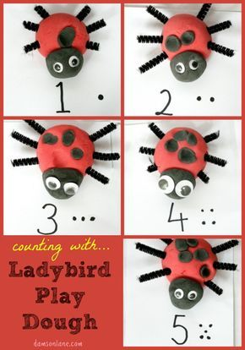  Make play dough using the recipe from the earlier timetables. This is a fun activity as you will ask your child to put spots on their ladybird. You can use numbers from 1-10 or 11-20. | -Baking.  Make ladybird cupcakes. There are so many recipes online. You can make any kind you like the photo is only a guide. Please feel free to make the cupcakes however you choose. Have fun. | - Take all your cushions, pillows and make a comfy space. Include your child’s favourite toys. Read together.
Thursday | - Look at the books your child has at home. Ask them to choose a book to look and read to them. Ask them questions about the story. Use the Oxford Owl books online if you have read all your books at home.  Look at the parent curriculum map for stories we are reading this term. | See Wednesday | -Sing some number songs with your children. This SHOULD BE DONE EACH WEEK.  You tube has a variety of number songs. Sing number songs each day.  Make up a number song, have fun. And include homemade instruments if you choose. Just go for it! | From Easter to Pentecost-  Talk about Jesus’ death and resurrection. Explain Christian belief in the resurrection and what we learn from that – that Jesus wasn’t like other people, he was God in human form.  Just as he cared for people throughout his life and after his resurrection we need to be like him and care for other people. Think about people you know who act with caritas (kindness to others). | -Have a bit of quiet time together if possible. Read a story and share a snack together.
Friday | -Practise name writing in book.  In the story what the ladybird heard, the ladybird did not talk in the beginning. Why do you think she didn’t talk? What made her change her mind and speak to the animals?  Draw the ladybird on the farm and include all her friends. Write next the animals what they said.  NB- ask them to use THEIR writing – which will be a mixture of mark making and letters – then to draw a picture. | - Sing Nursery rhymes with your child. There are hundreds of rhymes to learn. Look online or use the free book service to find nursery rhymes. | -Positional language game. Use your child’s favourite teddy for this game. Put a chair in a space and put the teddy on the chair. Ask your child is the teddy on top of, underneath, behind, beside, next to, in front of, on the chair. You can move the teddy around your home and still ask these questions. If your child tells you its there, say where? You are encouraging positional language. So try and get your child to give you an answer. | -Use your schoolbook to draw one of the animals from the story. Find out some information about that animal. Write down all the things you now know. You can write and draw more then one animal. | Follow the link and watch, Funny bones.  https://www.youtube.com/watch?v=Cfpk8QEhK1c  Every week in the nursery we watch a short book just for fun. Your child loves funny bones. This one is the pet shop. There are lots of other stories on you tube. Most of your children know the song at the beginning too!

