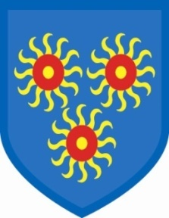
St Edmund’s Catholic Primary School

21sr July, 2022

To all Parents and Carers,

This will be the last time I write to you as Headteacher of St Edmund’s. It has been an adventure that I will never forget. I am truly grateful for the time that I have spent here; I have learnt so much from both the children and you, their parents. We have had many wonderful staff passing through our doors, we have won accolades and prizes and we have, together, built a happy and welcoming school community. I pray for the continued success of our school and send staff, parents and children all my very best wishes for the future.

The staff next year are as follows:

Executive Head Ms Diane Savva-Brown
Asst Head Ms Holly Simms
Asst Head/Year 6 Mr Conor McKenzie
Year 5 Ms Paulla Dean
Year 4 Mr Ricky Ramesar
Year 3 Mr James Fogarty
Year 2 Ms Laurel John
Year 1 Ms Jamie-Lee Curtale
Reception Ms Maria Charles
Nursery Ms Monica Gilhooly

The children will return to school on Wednesday, 7th September. I know you will join me in wishing Ms Savva-Brown every success and give her a very warm welcome.

I want to wish you all a very happy, peaceful and sunny summer.

My very best wishes,
Gail O’Flaherty

