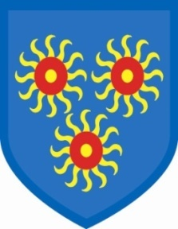
St Edmund’s Catholic Primary School

16th July, 2020
We have finally reached the end of this extraordinary year. I do hope that you have all continued to be safe and well. We said goodbye to Year 6 today, with a special Mass followed by an afternoon of activities. The governors and staff wish them every success for their futures.
In September, all of the children will be able to return, as the government has eased the restrictions imposed on us by the Covid crisis. There will still be restrictions in place and you will notice these as time goes on. We will be contacting you at the beginning of the new term in September to give you the times that your child’s class will start and end the day. You will not be allowed into the playground. If you need to come into the school for any reason, you will need to wait until all the children are in class and you will also need to let the admin staff know you are coming. Access to the school will be very restricted. I know you all understand the reasons for the restrictions.
Next year the teachers will be as follows:
Reception Maria Charles
Year 1 Mr Fogarty
Year 2 Mr Ramesar
Year 3 Ms Curtale
Year 4 Ms John
Year 5 Ms Libby
Year 6 Mr McKenzie

We are still working on how we can start the nursery class and we will contact the new nursery parents separately.

The children will start back at school on Monday, 7th September, as we will be spending the week before preparing the classes to ensure we comply with the new regulations.

We hope you all are able to enjoy your summer, whatever you are doing. I, personally, am really looking forward to being back in school and working with my fantastic team and all of your wonderful children.

Gail O’Flaherty

