Weekly plan for Caterpillars (15th-19th June)
Dear parents/Carers,
I have tried to design this timetable to make it as fun as possible for you and your child. I have put in examples to guide you, however, please feel free to use your imagination and go for it! Here is a rough timetable for you to use with your child if you have the time. We understand the pressures you are under and this is optional – it is just to support you as you spend time with your child. It is also important to remember that your child needs lots of brain breaks and opportunities for play (we know you know this)– role play, gardening (if this is possible), outside exercise (again, we know the limits), baking, drawing, painting etc.. Also, obviously feel free to do these activities when they suit you – you do not have to stick to the times on the timetable.
 | Literacy | Math’s | 1.30-1.45pm | 2.30pm – 3pm
Monday | New topic, “On the Farm.” Read “The Little Red Hen” https://www.youtube.com/watch?v=yclc22I4Zxk  Discuss the story together. Ask your child to retell the story to you.  Practise name writing each day. Remember to encourage your child to hold the pencil correctly. | Use one of the books you have for maths.  Draw lines across the page. At the beginning of each line write a number 1 with a circle next to it. Ask your child to tell you the number and how many circles you have. Then ask your child to write the number one and draw one circle only. Repeat this with numbers 2, 3, and 4. We always start off at number 1 in math’s books. | 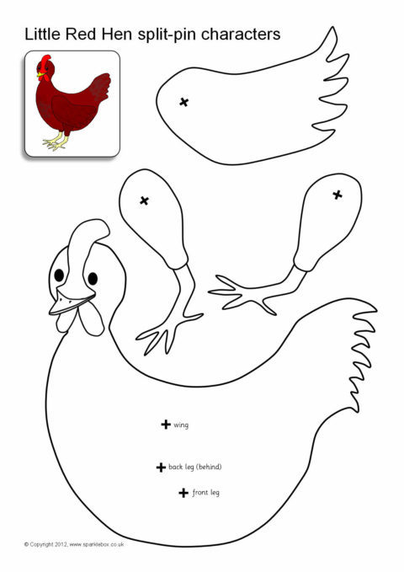  This is a great activity. You can cut out the hen and put the pieces together to make a split pin hen. You can do this with all the characters in the story. | -Have a bit of quiet time together if possible. Read a story and share a snack or two together.  Story time is especially important for your child.
Tuesday | -Practise name writing in the exercise book sent home. Write their name on a piece of paper first and ask them to copy it. Write with highlighter pen if they want to copy over a model.  Read the story again. If you were a pig what materials would you use to build a house? Use the internet to research a variety of materials. Draw your dream house and write why you have made it that way. | Repeat yesterday’s activity but with numbers 5,6,7,8.  If your child found yesterday’s one tricky just repeat. In nursery we always repeat activities to make sure the child understands and consolidates before we move on. | 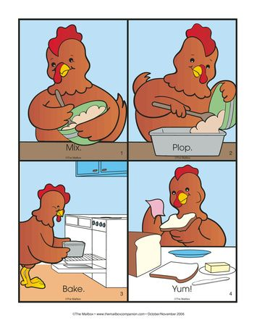  Sequencing a story is an essential skill the children learn in the nursery. The picture is one example. You can ask your child to draw different parts of the story then mix up the order. Ask your child to retell the story in the correct order. | Follow the link https://www.youtube.com/watch?v=y8vLjPctrcU. This shows children how wheat is made into flour. You tube has many educational videos to look at wheat and how it is grown.
Wednesday | Watch the video link.  https://www.youtube.com/watch?v=WYwjuufc19Q  This is an animated version of the book. Talk to your child about friendship and how they think the hen felt when her friends would not help her. Do you think the hen was right at the end to not share? What would you do? There is no right answer it is your child’s opinion and how they feel. Draw the little red hen and all write all the ingredients you need to make bread. | Each week make sure you do a shape activity. Shape recognition, hunting for shapes, making characters with shapes. Whatever you do make sure your child can name the shapes. Look at the properties too. Ask your child how many edges and corners. Practising each week keeps the information in your child’s memory. Even on your walks look for shapes. | Baking.  https://www.bbcgoodfood.com/recipes/bread-four-easy-steps  This simple bread recipe has 4 ingredients. You can add a variety of ingredients in your bread too. Talk to your child about each step and what happens to turn the ingredients into bread. | - Take all your cushions, pillows and make a comfy space. Include your child’s favourite toys. Read together.  https://www.youtube.com/watch?v=XpSLtVXF0Mc  Same, Different. A beautifully Illustrated book that looks at the beauty of children and helps to explain our differences and also how we are the same.
Thursday | - Look at the books your child has at home. Ask them to choose a book to look and read to them. Ask them questions about the story. Use the Oxford Owl books online if you have read all your books at home.  Look at the parent curriculum map for stories we are reading this term. | -Sing some number songs with your children. This SHOULD Be DONE EACH WEEK.  You tube has a variety of number songs. Sing number songs each day.  Make up a number song, have fun. And include homemade instruments if you choose. Just go for it! | RE: Explain that we use oil in Church sometimes to give a special blessing to people who are sick. (If you can ask your Priest to bring in the oil of Chrism to explain its use. )  Explain the word ‘anointed’ – having oil placed on our body (hands, forehead) – is a special sign of God’s love and care for us.  List the Sacraments which use oil: Baptism, when we become members of the Church; Confirmation, when we confirm our belonging in the church; the Sacrament of the Sick when we pray for people to feel strong again; Holy Orders, when a man becomes a priest.  Find pictures online to show how and  when we anoint people at Church we show our care and love for them and pray for them to be strong. | -Have a bit of quiet time together if possible. Read a story and share a snack together.
Friday | Read the Litte Ren Hen again. What characters were in the book? What did the animals say when the little red hen asked for help? Imagine this is you and your friends what would you say to your friends if they asked for your help? Draw a picture of you with your friends helping each other bake. Write what you would say to your friend.  . Write a list of all the materials they need. -NB- ask them to use THEIR writing – which will be a mixture of mark making and letters – then to draw a picture. | 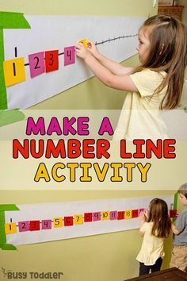  This is important to do each week. -Practise number writing. you can do this in their books or cut out pieces of paper and encourage your child to put the numbers in the correct order. | https://www.youtube.com/watch?v=gkLZKBFc2xY  The link shows your child one way to make jam. Ask your child what jam would they like with their bread if they were the hen. Make up your own jam recipe. What can you make using jam? Look online to find out. Jam biscuits, jam rolls, jam sponge cakes or jam tarts. Draw your favourite and write why it is your favourite. Maybe have a go at more baking. | Follow the link.  https://www.youtube.com/watch?v=6KuSl9eXgpk  Sharing a shell. This book is about kindness and sharing. Talk to your child about sharing and kindness. Why are these attributes so important? How do we feel when we share?

