From Advent to Christmas - Year C 1  Linking School, Parish and Home |  |  | 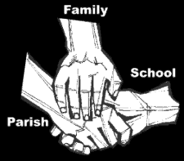
Religious Education
Key Idea:
This framework of learning is intended as the second in the Academic year 2018/2019. As the resource which teaches both Advent and Christmas it begins the Liturgical cycle of Year C – the Year of Luke. As the name suggests the content of this resource is the season of Advent and the birth of Jesus as recorded in the Gospel of Luke. It builds on the learning of the previous resource by further developing knowledge of God, in particular knowledge of the second person of the Trinity, Jesus, the Christ.

Attitudes and Spiritual Dispositions
Spiritual Outcomes: It is hoped that pupils will develop:  - A sense of wonder about the coming of God into the world  - A disposition of prayer | - An openness to the mystery of God, incarnate  - An appreciation of the gift of Christmas
Activities to try at home
You are the first educator of your child in faith. Your child’s learning in religious education will be much greater if you and the school are engaged in talking about the same ideas and beliefs. This resource teaches the practices of Advent and Christmas. Your children will be asked to think about their own birth and how you prepare for the birth of Jesus. Talk to them about what you do: do your rituals and customs reflect your cultural background?
An idea for prayer at home
Prayer Activity
Pray throughout Advent.

Make an Advent wreath and pray for the coming of God in Jesus.

God of hope, who brought love into this world, be the love that dwells between us.
God of hope, who brought peace into this world, be the peace that dwells between us.
God of hope, who brought joy into this world, be the joy that dwells between us.
God of hope, the rock we stand upon, be the centre, the focus of our lives always, and particularly this Advent time.

