Diocese of Westminster
St Edmund’s Catholic Primary School

School Uniform
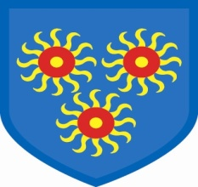

You have chosen to send your child to St Edmund's Catholic School where we are proud of our children in their uniform. Please help us to maintain our high standards by ensuring that your child has all the correct items of uniform.

BOYS Grey or black trousers or shorts
White polo shirt
Red school sweatshirt or plain red jumper
Grey or black socks
Black shoes or plain black trainers
Plain black, grey or navy coat / jacket

GIRLS Grey or black trousers, shorts or culottes
Grey skirt or pinafore dress
Red school sweatshirt or plain red cardigan
White polo shirt
Red and white check dress in the summer
Grey or white socks or tights
Black flat heeled shoes or plain black trainers
(Plain white trainers in the summer)
Plain black, grey or navy coat or jacket

PE KIT Navy or black shorts or leggings
Plain white T-shirt
White socks
Plimsolls
A plain navy or grey sweatshirt and track bottoms may be worn in cold weather
A plain swimming costume or trunks for swimming (you will be notified in advance when your child needs this)

The children look wonderful when they all have their uniforms on and we appreciate your help in ensuring that they are wearing the right items of clothing.

Red sweatshirts, school bags, baseball caps for summer and swimming caps can all be bought from the desk in the reception area.

