Weekly plan for Caterpillars (22nd-26th June)
Dear parents/Carers,
I have tried to design this timetable to make it as fun as possible for you and your child. I have put in examples to guide you, however, please feel free to use your imagination and go for it! Here is a rough timetable for you to use with your child if you have the time. We understand the pressures you are under and this is optional – it is just to support you as you spend time with your child. It is also important to remember that your child needs lots of brain breaks and opportunities for play (we know you know this)– role play, gardening (if this is possible), outside exercise (again, we know the limits), baking, drawing, painting etc.. Also, obviously feel free to do these activities when they suit you – you do not have to stick to the times on the timetable.
 | Literacy | Math’s | 1.30-1.45pm | 2.30pm – 3pm
Monday | New topic, “On the Farm.” Read “Mrs. Wishy Washy’s Farm.” Ask your child to retell the story. Ask questions. Did they enjoy the story? If yes why? If no, why not? Did they have a favourite character?  Practise name writing each day. Remember to encourage your child to hold the pencil correctly. | 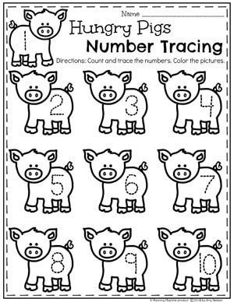  A fun way to trace numbers. You can draw any animal. It is important that your child keeps practising their numbers. | 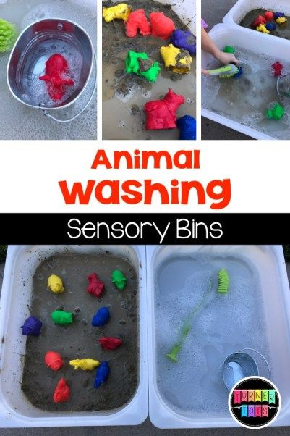  This activity is such good fun and an excellent sensory experience. You can put animal toys in the water and mud and have fun. Children love to explore a variety of textures. | -Have a bit of quiet time together if possible. Read a story and share a snack or two together.  Story time is especially important for your child.
Tuesday | -Practise name writing in the exercise book sent home. Write their name on a piece of paper first and ask them to copy it. Write with highlighter pen if they want to copy over a model.  Read the story again. Mrs. Wishy Washy is always washing those animals. Why? Do animals need baths? How do you keep animals clean? Ask your child what they think. Draw Mrs. Wishy Washy with her animals and write the names under the drawings. | Play board games with your child. This is such an easy way to incorporate numbers into your day. Games like bingo, snakes and ladders etc. you can play theses as a family. | Sequencing a story is an essential skill the children learn in the nursery. The picture is one example. You can ask your child to draw different parts of the story then mix up the order. Ask your child to retell the story in the correct order. | Follow the link to Mudchute Farm  https://www.mudchute.org/about-us  What a fantastic website. It is our local farm Mudchute. Find out all sorts of facts about the farm animals and local news.
Wednesday | Read the book again. Ask your child why having a bath is important. What makes having a bath extra special? Adding toys? Bubbles? Talk about routines. When do you have a bath? At night before story time? Do you have a bath before or after you brush your teeth? In the story the animals always have a bath. Why don’t the animals have a bath but a tub? When do you think it’s their bath time? Draw the animals in their tub. Write your routine down. | Each week make sure you do a shape activity. Shape recognition, hunting for shapes, making characters with shapes. Whatever you do make sure your child can name the shapes. Look at the properties too. Ask your child how many edges and corners. Practising each week keeps the information in your child’s head. Even on your walks look for shapes. | Baking.  By now all you adults must be expert bakers. Keep looking online for easy recipes. There are so many websites to choose from. Whatever you bake include your child as it’s a fun activity. | - Take all your cushions, pillows and make a comfy space. Include your child’s favourite toys. Read together.  https://www.youtube.com/watch?v=XpSLtVXF0Mc  Same, Different. A beautifully Illustrated book that looks at the beauty of children and helps to explain our differences and also how we are the same.
Thursday | - Look at the books your child has at home. Ask them to choose a book to look and read to them. Ask them questions about the story. Use the Oxford Owl books online if you have read all your books at home.  Look at the parent curriculum map for stories we are reading this term. | -Sing some number songs with your children. This SHOULD Be DONE EACH WEEK.  You tube has a variety of number songs. Sing number songs each day.  Make up a number song, have fun. And include homemade instruments if you choose. Just go for it! | RE: This term we have been looking at how we treat each other, sharing and kindness.  Follow the link  https://www.youtube.com/watch?v=AaNHGSNMyPM  The story is called the big bad mood. It explores feelings. It is an imaginative way to look at children’s moods with fun. Toy can talk to your child about their feelings and how they feel when they get into a mood. What helps them calm down? In school we have lots of carpet sessions about feelings. By talking to the children we can find out lots of information. | Follow the link  https://www.youtube.com/watch?v=SIbGioTNs4M  The book is called Mixed a colourful story. It is a magical story about colour and friendship. The story has such a beautiful message and will stay with you and make you feel good, enjoy.  -Have a bit of quiet time together if possible. Read a story and share a snack together.
Friday | Read the story again. What animals were in the story? Why did they run away? Discuss what happened when they ran away, was life better? What did the animals all learn by returning home? The animals are Mrs. Wishy Washy’s family. What does your family look like? All families are not the same. Draw a picture of your family and write each person’s name underneath. What makes your family so special?  Write a list of all the materials they need. -NB- ask them to use THEIR writing – which will be a mixture of mark making and letters – then to draw a picture. | 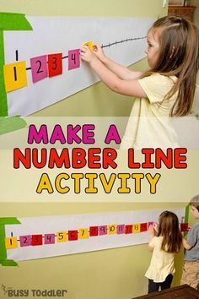  This is important to do each week. -Practise number writing. You can do this in their books or cut out pieces of paper and encourage your child to put the numbers in the correct order. | 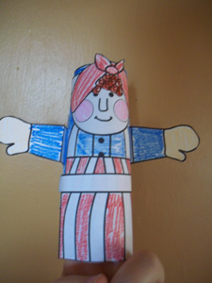  Don’t throw your toilet rolls away! Use them to make Mrs. Wishy Washy. You can make the other animals in the story too! | Follow the link. David gets in trouble.  https://www.youtube.com/watch?v=nV4ZYfPPftI  In this story a boy called David causes lots of accidents! Talk to your child about each page and if they think David did have an accident or do things on purpose. Children look at things quite differently to us and you might be surprised by their answers.

