Weekly plan for Caterpillars (13th -17th July )
Dear parents/Carers,
I have tried to design this timetable to make it as fun as possible for you and your child. I have put in examples to guide you, however, please feel free to use your imagination and go for it! Here is a rough timetable for you to use with your child if you have the time. We understand the pressures you are under and this is optional – it is just to support you as you spend time with your child. It is also important to remember that your child needs lots of brain breaks and opportunities for play (we know you know this)– role play, gardening (if this is possible), outside exercise (again, we know the limits), baking, drawing, painting etc.. Also, obviously feel free to do these activities when they suit you – you do not have to stick to the times on the timetable.
 | Literacy | Math’s | 1.30-1.45pm | 2.30pm – 3pm
Monday | Our topic has been, “On the Farm.” Think about all the books you have read. What one was your favourite? Why? Draw your favourite book and write underneath why it was your favourite..  Discuss the story together. Ask your child to retell the story to you.  Practise name writing each day. Remember to encourage your child to hold the pencil correctly. | 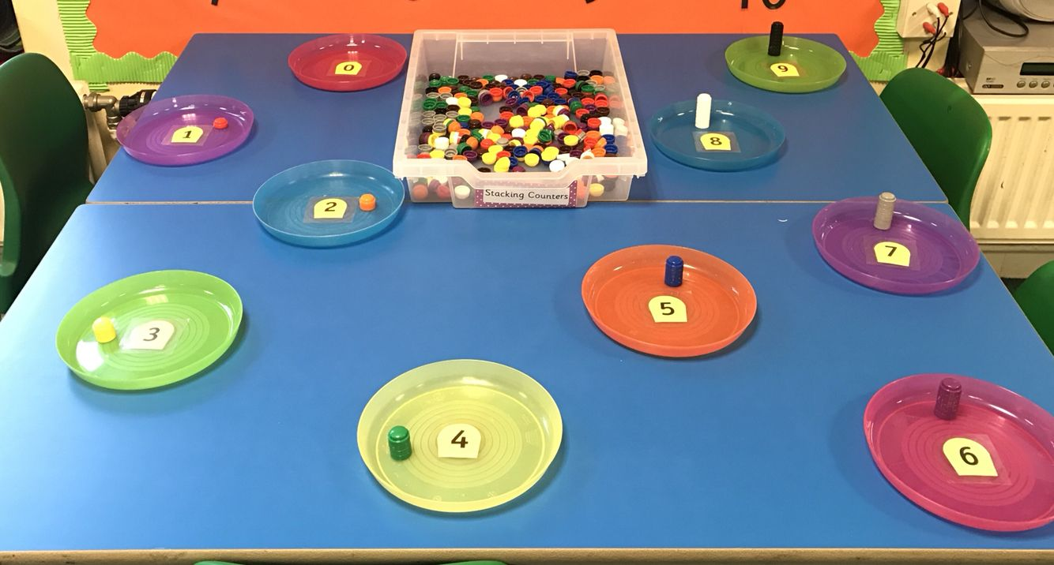  Fun math’s activity. Number plates and ask your child to tell you the number and then find that many. Go as high as your child can recognise. | 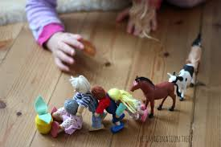  Create your own story sack. All you need are the animals and farmer from the story. If you do not have farm animals then use paper to draw them, toilet rolls to make them or even wooden spoons. Let your child then retell the story. You will find your child may add more to the story which is great as they are using their imagination. Do this activity weekly to encourage language. | -Have a bit of quiet time together if possible. Read a story and share a snack or two together.  Story time is especially important for your child.
Tuesday | -Practise name writing in the exercise book sent home. Write their name on a piece of paper first and ask them to copy it. Write with highlighter pen if they want to copy over a model.  Look at all the animals from all the stories we have been reading. Which animal did you like the best? Why did you like that animal the most? Did you learn anything new about that animal? Write a list of your new information with pictures. | 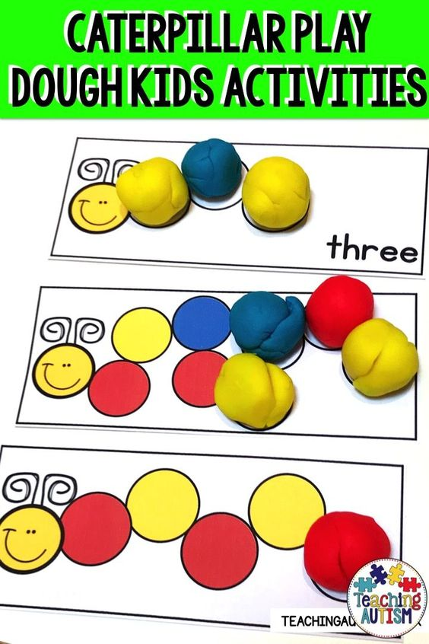  Don’t forget patterns. You can draw these in your child’s book and ask them to choose two colours, then repeat a pattern. | Ask your child to draw pictures from parts of the story. Cut out the pictures. Mix them up. Sequencing a story is an essential skill the children learn in the nursery. The picture is one example. You can ask your child to draw different parts of the story then mix up the order. Ask your child to retell the story in the correct order. | Follow the link, My first day of school.  https://www.youtube.com/watch?v=6b38qk14di4  Talk to your child about how they are feeling. Are you excited to come back to school? How do you feel meeting a new teacher? Have you missed your friends? What do you think you will learn in Reception?
Wednesday | Watch the video link.  https://www.youtube.com/watch?v=55bwyoQxmm0  This video shows you how a vet looks after pets. | Each week make sure you do a shape activity. Shape recognition, hunting for shapes, making characters with shapes. Whatever you do make sure your child can name the shapes. Look at the properties too. Ask your child how many edges and corners. Practising each week keeps the information in your child’s head. Even on your walks look for shapes. | Baking. I am sure all of you are now experts at baking. It is an essential activity in the nursery to encourage your child to use their language. It is also a great activity to do as a family. Enjoy! | - Take all your cushions, pillows and make a comfy space. Include your child’s favourite toys. Read together.
Thursday | - Look at the books your child has at home. Ask them to choose a book to look at and read to them. Ask them questions about the story. Use the Oxford Owl books online if you have read all your books at home.  Look at the parent curriculum map for stories we are reading this term. | -Sing some number songs with your children. This SHOULD Be DONE EACH WEEK.  You tube has a variety of number songs. Sing number songs each day.  Make up a number song, have fun. And include homemade instruments if you choose. Just go for it! | RE: Talk about which of the virtues the Samaritan showed. Make a list of the ways we can act with each virtue: eg being fair…in games, listening to others, sharing, offering to help etc. Explain that we can be like the Samaritan when we use these virtues.  Use the ‘virtues’ in discussions of behaviour and when you are praising or reminding children. Praise children when they act appropriately. | -Have a bit of quiet time together if possible. Read a story and share a snack together.  Remember to look back at past timetables to revisit books your child enjoyed.
Friday | Read “I Love Animals.” Why do we love animals so much? Do you have a pet at home? Do you look after it or does your grown up? Talk about being kind to the animals and how you can look after them. Draw the animals from the book and write how you would look after them.  . Write a list of all the materials they need. -NB- ask them to use THEIR writing – which will be a mixture of mark making and letters – then to draw a picture. | 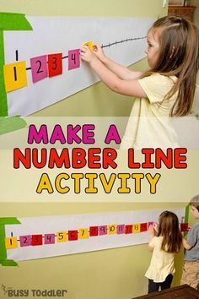  This is important to do each week. -Practise number writing. You can do this in their books or cut out pieces of paper and encourage your child to put the numbers in the correct order. | Talk about what you now know about the topic, On the farm. What have you learned? Write a list of facts. Did you use the Mudchute farm website to find out more facts about the farm? | Follow the link. The Bumblebear.  https://www.youtube.com/watch?v=o6ZaSM6sNGw  This is such a good story about a bear that loves honey. You will laugh together at the lengths he goes to for honey. A funny story to share with the family.

