Weekly plan for Caterpillars (8th-12th June)
Dear parents/Carers,
I have tried to design this timetable to make it as fun as possible for you and your child. I have put in examples to guide you, however, please feel free to use your imagination and go for it! Here is a rough timetable for you to use with your child if you have the time. We understand the pressures you are under and this is optional – it is just to support you as you spend time with your child. It is also important to remember that your child needs lots of brain breaks and opportunities for play (we know you know this)– role play, gardening (if this is possible), outside exercise (again, we know the limits), baking, drawing, painting etc.. Also, obviously feel free to do these activities when they suit you – you do not have to stick to the times on the timetable.
 | Literacy | Math’s | 1.30-1.45pm | 2.30pm – 3pm
Monday | New topic, “On the Farm.”  Read “The Three Little Pigs. https://www.youtube.com/watch?v=xGFjzp8wl1E  Discuss the story together. Ask your child to retell the story to you.  Practise name writing each day. Remember to encourage your child to hold the pencil correctly. | Cut out shapes, circles, triangles, rectangles and squares. Make a house for the pigs using a variety of shapes. Ask your child to name each shape. | 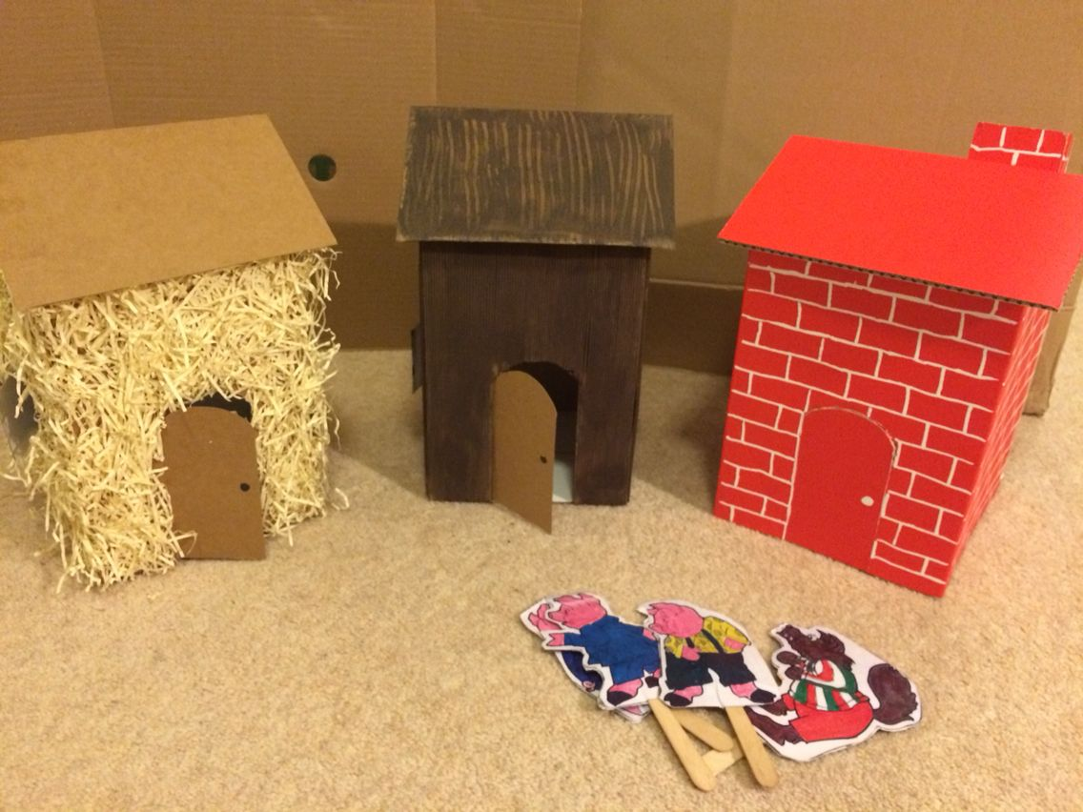  Use whatever materials you have available to make a house for the three pigs. | -Have a bit of quiet time together if possible. Read a story and share a snack or two together.  Story time is especially important for your child.
Tuesday | -Practise name writing in the exercise book sent home. Write their name on a piece of paper first and ask them to copy it. Write with highlighter pen if they want to copy over a model.  Read the story again. If you were a pig what materials would you use to build a house? Use the internet to research a variety of materials. Draw your dream house and write why you have used those materials. | Math’s aerobics. Take numbers from 1-10 outside with you. Give the children a number and ask them what it is. Then get them to do that many jumps, squats, star jumps, spins etc. Great exercise too! |  | Follow the link https://www.youtube.com/watch?v=6XCyoM7KHws This story is called “Same, Same But Different”. It beautifully looks at people and how we are different but the same. A great story to encourage your child to talk about what they see and the beauty of our differences.
Wednesday | Watch the video link. All about pigs.  https://www.youtube.com/watch?v=6xpTNDDI-iw  What have you learned about pigs? Can you draw a picture of a farm and add a pigsty with a variety of pigs. What do you think is important when looking after pigs? What do they need? Write this at the bottom of your picture. | 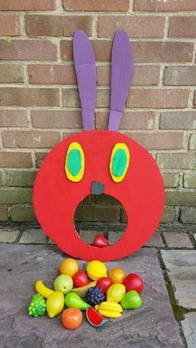  This game is great fun. Use any toys available to play. Show your child a number and they must put that many toys through the mouth. Can roll a dice to count spots to change it up. | 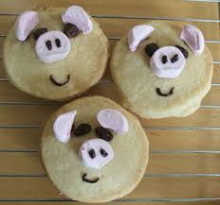  Baking.  Follow the simple biscuit recipe from before. These biscuits are just a guide, let your imagination go wild and make whatever type of pig biscuit you like. Have fun! | - Take all your cushions, pillows and make a comfy space. Include your child’s favourite toys. Read together.
Thursday | - Look at the books your child has at home. Ask them to choose a book to look and read to them. Ask them questions about the story. Use the Oxford Owl books online if you have read all your books at home.  Look at the parent curriculum map for stories we are reading this term. | -Sing some number songs with your children. This SHOULD Be DONE EACH WEEK.  You tube has a variety of number songs. Sing number songs each day.  Make up a number song, have fun. And include homemade instruments if you choose. Just go for it! | RE: Recall that the story of the Good Samaritan is an example story and that we are called to act like the Samaritan – he is the example!  http://www.youtube.com/watch?v=u9r8AvPM02w – Watch the beginners bible story.  THEN:  Explain that the Church has a list of things we can do to be like the Good Samaritan. These actions are called virtues. List and explain the virtues; being fair [justice], thinking before you do something [prudence]; being brave [courage] and waiting for others – being patient [restraint].  http://www.youtube.com/watch?v=8j2PUWQa7fs&index=3&list=PLHnmDpjKrtBFQ-SGK-J5GhgTl6WGO-LPc  Link to the fruit of the spirit – ‘But the fruit of the Spirit is love, joy, peace, patience, kindness, goodness, faithfulness, gentleness and self-control.” | -Have a bit of quiet time together if possible. Read a story and share a snack together.
Friday | Read the Three little wolves and the big bad pig.  https://www.youtube.com/watch?v=xxhaMmsXYmo  What did you think of the story? What was the pig like? Did you find the story funny? Can you tell your adult your favourite part of the story?  Draw the three little wolves building a house together. Write a list of all the materials they need. -NB- ask them to use THEIR writing – which will be a mixture of mark making and letters – then to draw a picture. | 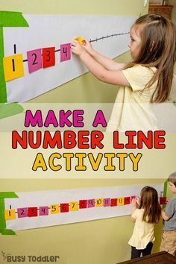  This is important to do each week. -Practise number writing. you can do this in their books or cut out pieces of paper and encourage your child to put the numbers in the correct order. | -Use your schoolbook to draw one of the animals from the story. Find out some information about that animal. Write down all the things you now know. You can write and draw more than one animal .  This activity your child did last term but it will work for this book too. In nursery we try and reinforce their learning by repeating some activities. | Follow the link.  https://www.youtube.com/watch?v=ifXlc0QI2kY  This story is the Rainbow fish. This short video is all about a fish learning the meaning of kindness. Talk to your child and ask them why being kind is so important. How do your friends feel when we are not kind?

