Discipleship - Year B  Linking School, Parish and Home |  |  | 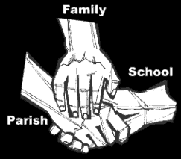
Religious Education
Key Idea: Discipleship
This framework of learning is intended as the final resource for the Summer Term in the academic year 2017/2018. It completes study of the Gospel of Mark by examining one of his strongest themes: discipleship. Building on the work of the previous unit, this resource picks up the actions of the disciples in Mark’s Gospel as we identify what it is that Jesus asks of those how follow him.
Attitudes and Spiritual Dispositions
Spiritual Outcomes: It is hoped that pupils will develop:  - An openness to following the life and teaching of Jesus  - An awareness of the way that people around them live as contemporary followers | - An attitude of hope in responding to the challenges of being a disciple
Activities to try at home
You are the first educator of your child in faith. Your child’s learning in religious education will be much greater if you and the school are engaged in talking about the same ideas and beliefs.
- In the Gospels of Luke and Matthew the disciples ask Jesus to teach them a prayer. He responds by teaching them the Our Father. Pray the prayer of the disciples with your children.

An idea for prayer at home
Prayer Activity
Pray the Our Father with your children before bed.

