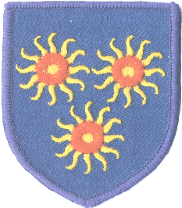

St Edmund’s RC Primary School
Diocese of Westminster
www.st-edmunds.towerhamlets.sch.uk
Follow us on @stedmundsschoo1

Newsletter to Parents

9th March 2018

Lenten appeal – Collection for the victims of Hurrican Maria in Puerto Rico  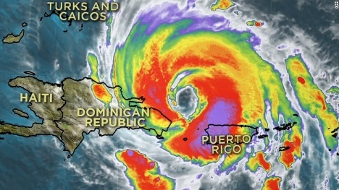  Although Hurricane Maria struck Puerto Rico in October 2017, this hurricane was the most powerful and intense cyclone of 2017, globally. Many people are still homeless and lacking basic facilities such as running water and electricity.  The money raised by our Lenten appeal will help families cope with the continuing difficulties.  Class Assemblies  Due to the closure last week, the rota has changed again. It is as follows:  Year 4, 9th March  Year 5, 16th March,  Year 6, 23rd March | Book Week  As part of our Book Week celebration, books will be on sale in the school hall, at 3.30pm from Thursday, 22nd March, through to Tuesday, 27th March.  Maths Challenge Week  This will take place during the week beginning Monday, 19th March.  Look out for the sign-up sheets coming soon on the school’s main reception doors, where you can join your child in class for a lesson.  Absences or Running Late?  Please can you inform the school by 9.10am, if your child will be absent, or that you are going to be late. This is so that we can work out how many school dinners will be required for that day.  A Packed Lunch or a School Dinner?  Children should choose a packed lunch or a school dinner for the whole of a half term. At the end of a half term, please let the school office know if you are changing from one to the other.  Easter Holiday  The last day of school is Thursday, 29th March. School will finish at 2pm and there will be no after school care or clubs on this day.  Nut Free School  As some of our children have a very serious allergy to nuts, please do not pack any nuts in packed lunches, or snacks.

