Hi Year 1 parents,
We’re back to online learning which is far from ideal. You might be feeling stressed about your child making progress. I would say not to worry – try your best to follow along with the work through google classroom and we will be alright.
Please take note of the following:
- Routine is the most important aspect of home learning. Decide what time you are going to do maths and English each day. Decide on a place in your home to do the work e.g., the kitchen table. This way when your kid sits down at the table, they know they are sitting down to do some work.
- You don’t need to replicate the 9am – 3:30pm school day. Try this - 30 minutes of maths, 30 minutes of English, 15 minutes of reading, and practice some spellings.
- Please be patient whilst we get going with google classroom. You will receive a new invite to a new classroom titled ‘Year 1 - 2020-21’. I’ll be making phone calls this week to make sure everyone is able to access this. Everything will be running smoothly by Monday.
- Each Sunday night a weekly timetable will be uploaded. This will include details of 5 maths lessons and 5 English lessons. Each week there will be an opportunity to upload children’s writing and I will give you feedback on it.
- We will also have an art or a science activity to do each week. This is something that you could tackle at the weekend.
- You won’t need a printer. But sometimes you will need to have prepared something prior to your child doing the work e.g. you might need to draw a grid, or the outline of a character, or have written a handful of addition sentences.

Below is a small timetable with some maths and English tasks for Wednesday, Thursday, and Friday. It will be more structured and easy to follow once we are working through google classroom on Monday.

Timetable for Year 1 Week Beginning 6th January 2021
Monday | Tuesday | Wednesday | Thursday | Friday
 |  | Maths  Addition Revision  Please follow the instructions for completing additions.  Solve some additions with numbers under 20 following the first method. Then try to solve some with the 2nd and third methods.  Step 4 is only to challenge people who have mastered the above. It’s not necessary. | Maths  Subtraction Revision  Please follow the instructions for completing subtractions.  Similar to Wednesday start with the practical method using blocks to subtract with, then move on once comfortable.  Again step 4 is just an extra challenge and not necessary. | Maths  Practice counting with the 100 square. Cover up numbers, ask which number is hidden.  Find and point to 23, 54, 16, etc.  Find 23. What is one more? Model moving your finger to find one more. Go back to 23. What is 1 less?  Complete the table for Friday maths.
Break
 |  | English  Google the book ‘No Thank You’ By Ruth Merttens (the first page is a big picture of a Zebra).  Read through the story with your child. Give help when needed but encourage them to use phonics and robot arms for words they do not know.  After reading try one of these activities.  Activity 1: Write sentences to match up the animals with the mismatched food they were offered. E.g. The flamingo got the mango.  Extend these sentences with the conjunction ‘but’  The flamingo got the mango but I would give it/it should have got the worms. This doesn’t have to be right, let the children make a best guess.  Activity 2. Draw a picture of a meal love to eat. Complete with drinks and deserts. Label all the different foods on your plate and side plate. | English  Re-read No Thank You! Each time you reach the line, ‘No thank you!’, say the words in an appropriate voice – rather cross, very firm, puzzled, maybe a bit upset. Can you give the animals voices?  After reading try one of these:  Activity 1: Look at the picture of the lion. What great words could we use to describe the lion? Share ideas: golden, big, scary, fierce, sleepy, shaggy, etc. Now do the same thing for the snake, the pelican and the bat. Write the words around a picture of the animal.  On four strips of paper (adult) write out the jumbled-up sentences. Kids cut these up and reorder them to make sense.  Activity 2. What is your favourite animal from the story? Draw a picture of it on My Favourite Animal and write about why you like it the best. | English  Re-read No Thank You! for the last time. Once again, say the animals’ ‘No thank you!’ line in a characterful way. Also add in appropriate ‘no thank you’ actions – shaking your head, turning way, crossing your arms, looking cross, wagging a finger, etc.  Get ready to write your own version of ‘No Thank You!’, featuring new animals and foods. Use the Story Planner (below this) to record which three animals will be in your story, which funny foods they will be given and what they will say.  Harder: Include a really good describing word or words for each animal and each food on your Planner: e.g. enormous dog and juicy green lettuce.  If your child is struggling to plan and write a sentence try this. Think of a sentence with them – try keep it at about 5 words. Say the sentence over and over. You write the sentence on a strip of paper whilst saying the words aloud. They watch you do this. Read the sentence with them. Cut it up and let them reordered. Once it’s reordered let them copy it.

Wednesday Maths Revision
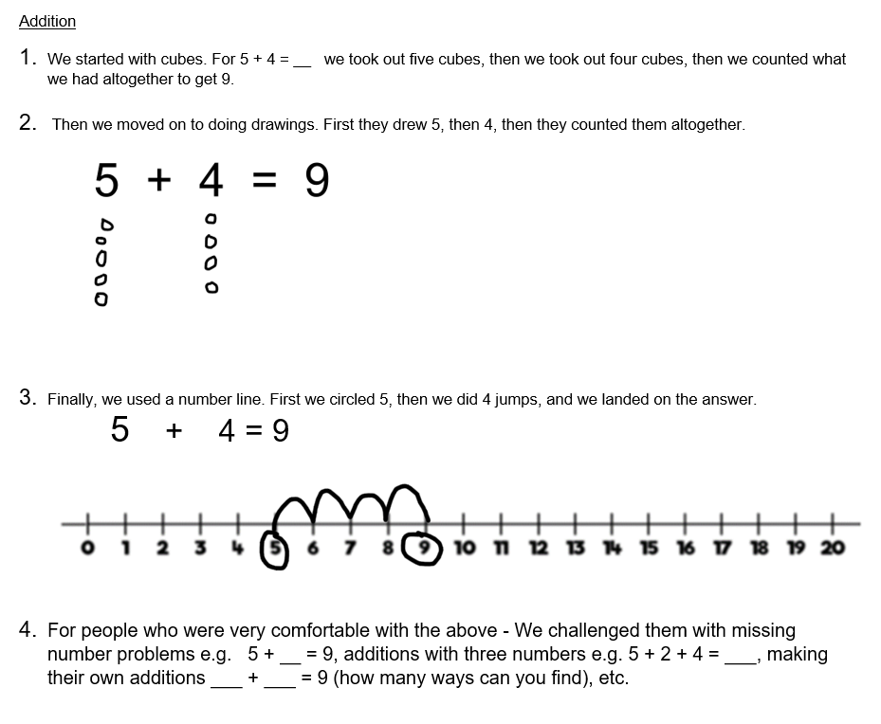
Thursday Maths Revision
