Weekly plan for Caterpillars (1st- 5th June)
Dear parents/Carers,
I have tried to design this timetable to make it as fun as possible for you and your child. I have put in examples to guide you, however, please feel free to use your imagination and go for it! Here is a rough timetable for you to use with your child if you have the time. We understand the pressures you are under and this is optional – it is just to support you as you spend time with your child. It is also important to remember that your child needs lots of brain breaks and opportunities for play (we know you know this)– role play, gardening (if this is possible), outside exercise (again, we know the limits), baking, drawing, painting etc.. Also, obviously feel free to do these activities when they suit you – you do not have to stick to the times on the timetable.
 | Literacy | Math’s | 1.30-1.45pm | 2.30pm – 3pm
Monday | New topic, “On the Farm.” We will be reading, Farmer Duck. https://www.youtube.com/watch?v=wn4b9AqiUbw  What was the story about?  Can you remember all the animals from the story? What was farmer ducks job? Do you have jobs at home?  Encourage your child to retell the story.  Practise name writing each day. Remember to encourage your child to hold the pencil correctly. | 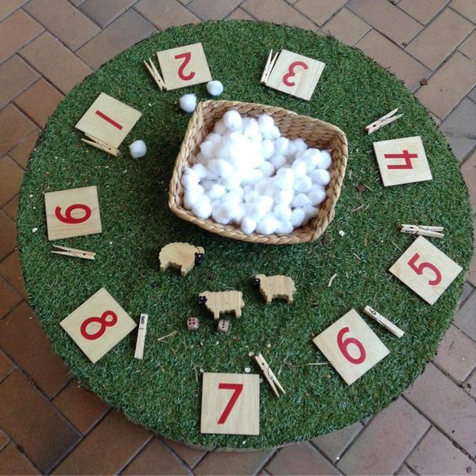  You can make your own math’s game. You can use numbers from 1-10 or 11-20. Put any objects you have in the centre for your child to count out correctly. | 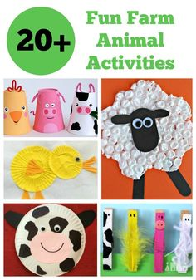  These are some ideas to make animals with your child. Using a variety of materials you have at home. | -Have a bit of quiet time together if possible. Read a story and share a snack or two together.  Story time is especially important for your child.
Tuesday | -Practise name writing in the exercise book sent home. Write their name on a piece of paper first and ask them to copy it. Write with highlighter pen if they want to copy over a model.  Read the story again. Did you like the farmer? If you were in charge what would you say to the farmer? Would you make him get up? Get dressed? Help? Write down your ideas and draw a picture of the farm.  If Mud chute is open maybe visit the farm if you are able to and talk about all the animals you can see. | 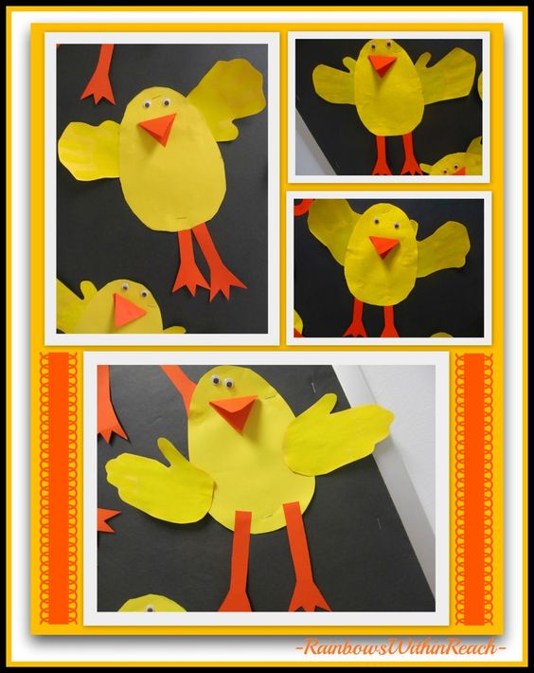You can make ducks and put numbers on them from 1-10. Mix them up and ask your child to put them in the correct order. | 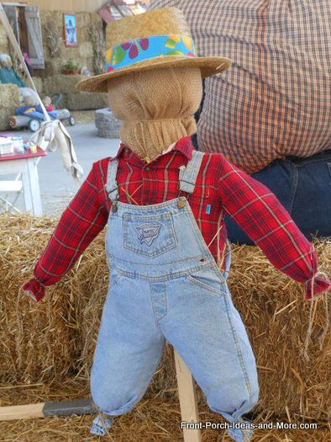  Time to dig out your child’s old clothes and have fun! make a scarecrow together. You can stuff it with old clothes, papers, magazines or even newspapers. Enjoy!! | Watch Fun facts about ducks.  https://www.youtube.com/watch?v=zjvP3_DWK2I  Ask your child if they remember any duck facts. You can make a little book together and write all the fun facts you now know.
Wednesday | Watch the video link. A day on the farm. https://www.youtube.com/watch?v=oaXFKlYm11o Thinking of the book, Farmer Duck, did the farmer do any of those jobs? Make a list of jobs a farmer should do. Draw pictures next to each job. | 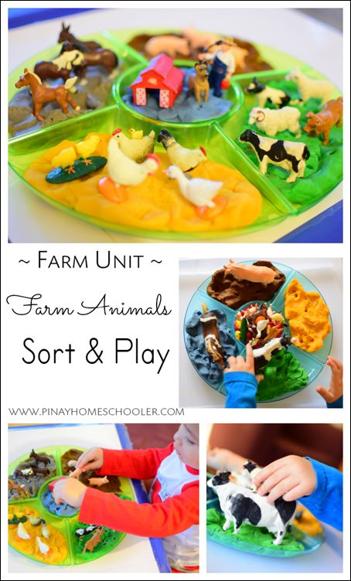  Remember sorting out toys, objects is math’s. Put a mixture of objects in the middle and ask your child to sort them into groups. | 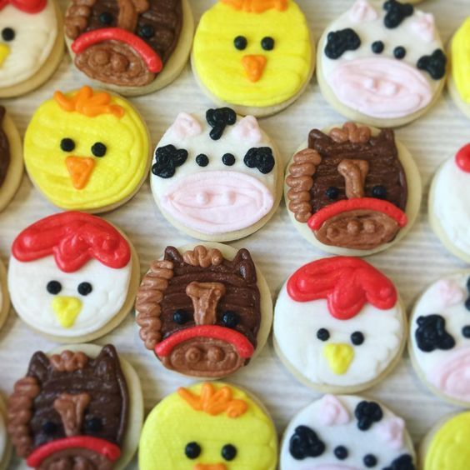  Baking.  Animal biscuits. Lots of recipes online. Baking encourages your child’s communication skills and math’s too. This is such an important activity. | - Take all your cushions, pillows and make a comfy space. Include your child’s favourite toys. Read together.
Thursday | - Look at the books your child has at home. Ask them to choose a book to look and read to them. Ask them questions about the story. Use the Oxford Owl books online if you have read all your books at home.  Look at the parent curriculum map for stories we are reading this term. | -Sing some number songs with your children. This SHOULD Be DONE EACH WEEK.  You tube has a variety of number songs. Sing number songs each day.  Make up a number song, have fun. And include homemade instruments if you choose. Just go for it! | RE: The Kingdom of God.  Jesus teaches us that all people have dignity and worth and that regardless of whether people are our friends or not, we are called to show compassion to all. – Have pictures of a range of different people from around the world and talk about our differences  (Use google or you tube for the pictures)– How are you different to the person next to you? Is difference bad? Does it mean we cannot like someone because they are different?  Talk about how some people look different from us and that we might be frightened of them because we don’t know them well.  When we get to know people we find they are just like us! | -Have a bit of quiet time together if possible. Read a story and share a snack together.
Friday | -Practise name writing in book.  In the book, Farmer Duck what kind of person was the farmer? Was he kind? Happy? Mean? Lazy? Fat? Talk to your child and encourage your child to describe the farmer. Now talk about farmer duck. What was he like? How do you think he felt doing all the work? Was it fair? What do we say in school about sharing and being kind to each other? Draw farmer duck with all his farm friends.  NB- ask them to use THEIR writing – which will be a mixture of mark making and letters – then to draw a picture. | -Practise number writing.  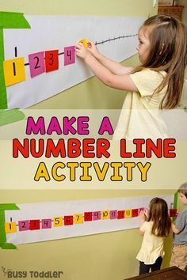  you can do this in their books or cut out pieces of paper and encourage your child to put the numbers in the correct order. | -Use your schoolbook to draw one of the animals from the story. Find out some information about that animal. Write down all the things you now know. You can write and draw more than one animal .  This activity your child did last term but it will work for this book too. In nursery we try and reinforce their learning by repeating some activities. | Follow the link. https://www.youtube.com/watch?v=TyrmcD8Yml0  This is the story of the ugly duckling. This story ties in nicely with the RE. you can talk to your child and discuss what makes us different, is it ok to not all be the same? Does it matter? Should we all look alike? What is important ? inside we are all the same and should show each other kindness.

