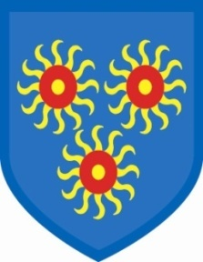
St Edmund’s Catholic Primary School

March 17th, 2020
Dear Parents/Carers,
Some of you are aware that I have a degenerative illness that affects all my muscles, including my lungs. I have today been advised that I will need to self-isolate for a significant period of time. I have a very strong Leadership Team and they will be supporting me as I work from home.
However, if you need to speak to anyone straight away, the Leadership Team, comprising of Mr Ramesar, Debbie Halpin-Lowe, Mr McKenzie, Ms John and Holly Simms, are all making themselves available at the beginning and the end of the day for you to talk to. Jo Hannan is still happy to direct your concerns or queries to the right person and Shenaya is always available to take any messages. Staff will send anything to me that I need to deal with or know about.
We have also made the decision to cancel class assemblies for the forseeable future, to minimize close contact with other adults and family members. This will be reviewed regularly. There will be no Reception class assembly this Friday.
The government advice is that anyone with a cough or a temperature should self-isolate for 14 days, with their family members. I also understand that a statement will be made shortly about financial support. Please do follow the self-isolation advice. Schools are now having to close due to lack of staff.
If we do close, we will send home details of work that your child can do at home.
Keep yourselves and your families safe.

Gail O’Flaherty
Headteacher

