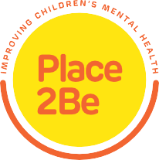Coffee Morning

A coffee morning will take place on 24/03/2022 at 10:00- 11:00am with Maria Troupkou, the School Project Manager of Place2be and Nadezhda Chavdarova, the Family Practitioner of Place2be.
Meet other parents and discuss about the impact of labeling and how you can support your children to express their emotions.
To Join us (ZOOM) send an email to maria.troupkou@place2be.org.uk
