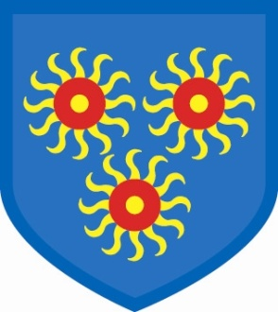
St Edmund’s Catholic Primary School
Diocese of Westminster
Follow us on @stedmundsschoo1
For school information: http://www.stedmunds.towerhamlets.sch.uk/


Thursday, 18th May
Sport’s Day

This is taking place next week on Thursday, 25th May. We look forward to seeing you at 1.30pm and don’t forget your trainers for the parent race!
Talent show
This will be taking place on Friday, 9th June at 6.30pm. Tickets will soon be on sale and are £4 for adults and £2 for children.
School website
This is now back up and running so please check it for up to date information. Please follow us on
Twitter @stedmundsschoo1
Polling Day
Our school will be a polling station for the general election on Thursday, 8th June and therefore the school will be closed.

Class assemblies

19th May: Year 5
26th May: Year 4
Half Term
9th June: Year 6
16th June: Year 3

Dates for the diary
May half term: 29th May – 2nd June
School closed (polling day): 8th June
Talent show: Friday, 9th June
Whole school trip to Joss Bay: Tuesday, 20th June
(more information to follow)

.

Year 3 have been learning about Light in Science
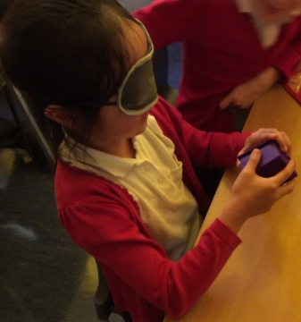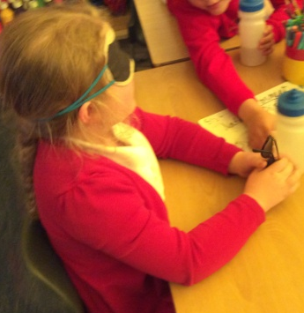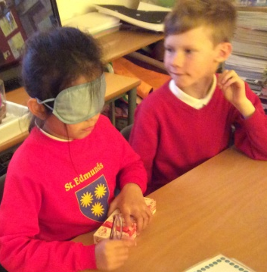
We need our eyes to help us see. We explored what it would be like to have no light and to try and identify objects.

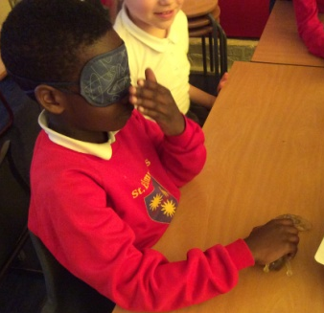
We designed items to protect Mrs. Evans’ eyes from light sources.

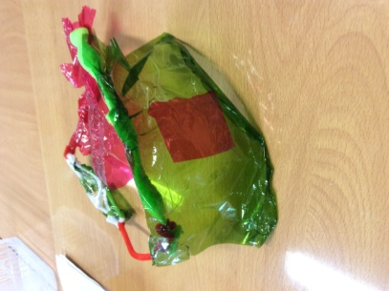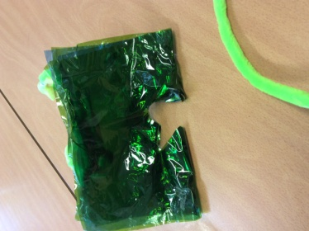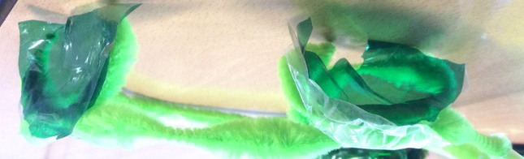
In History we have been learning about the changes that occurred between the Stone Age and Iron Age. We are making houses for each period in history.



