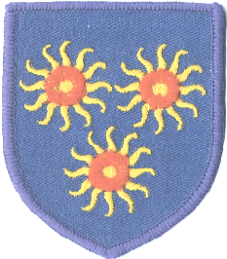 **Newsletter to Parents**

St Edmund’s RC Primary School

Diocese of Westminster

**30th June 2017**

**You can now see this newsletter on our website**

[**www.st-edmunds.towerhamlets.sch.uk**](http://www.st-edmunds.towerhamlets.sch.uk)

**St Edmund’s Got Talent!**

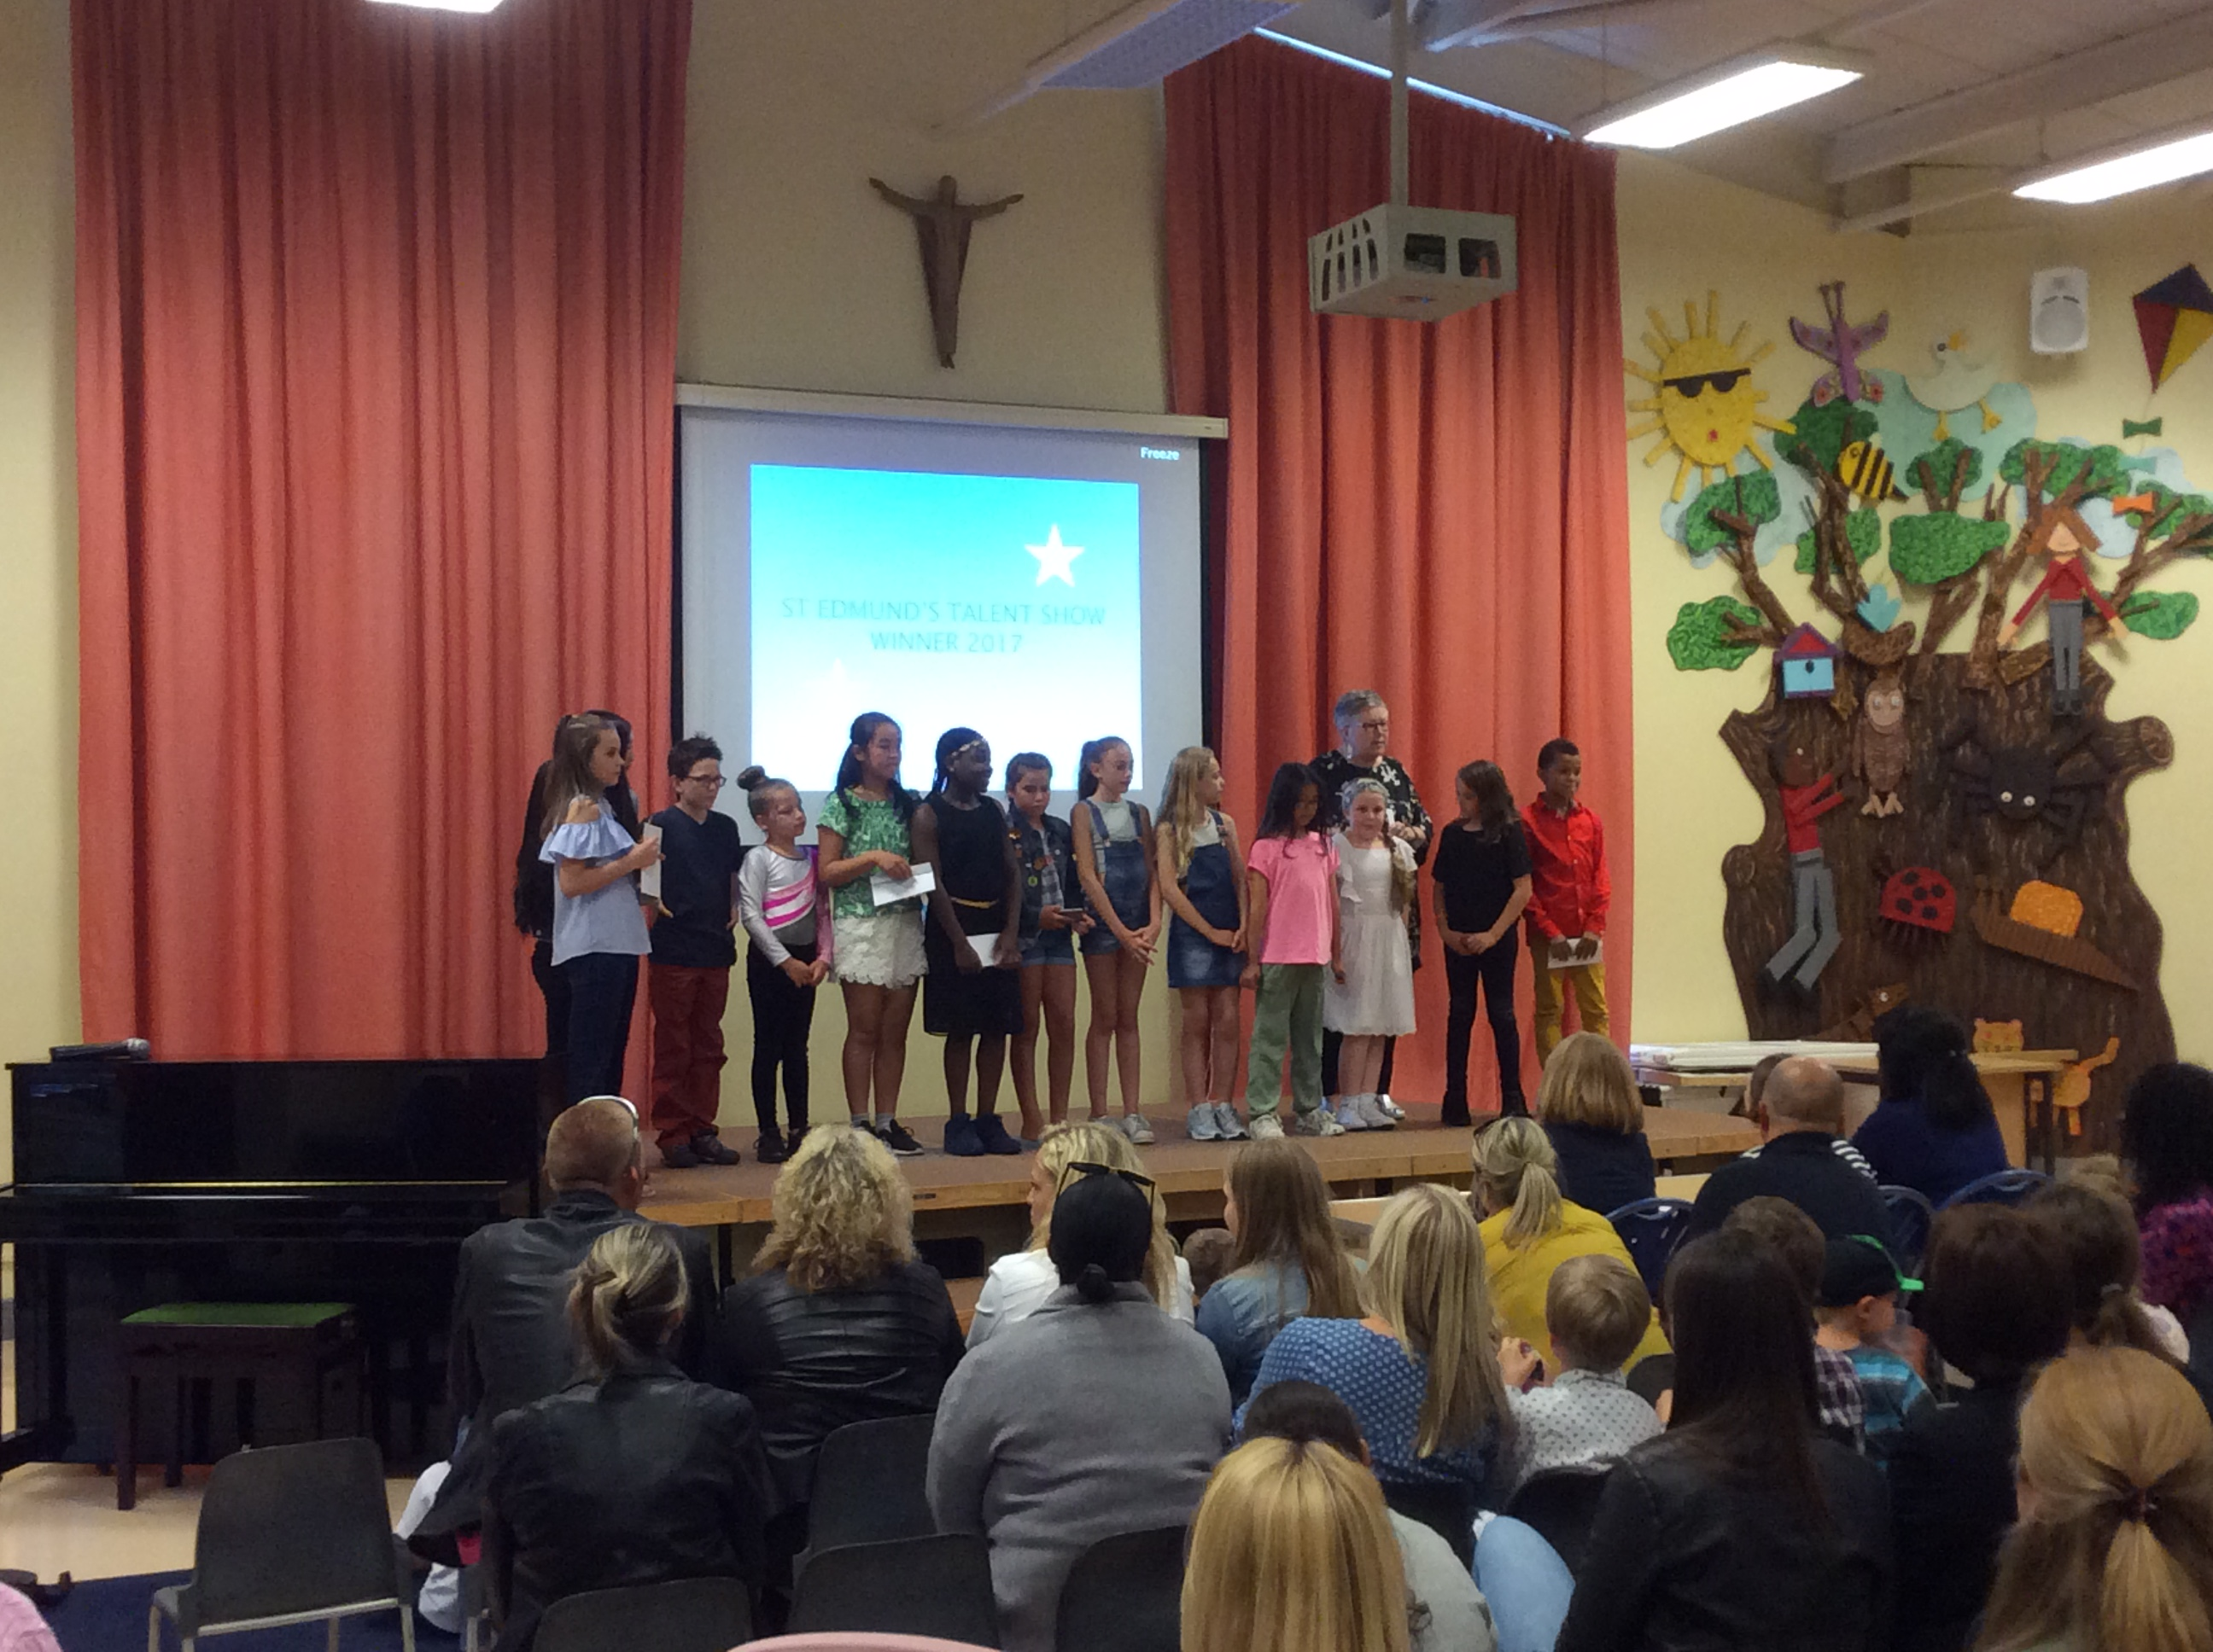

A fabulous evening of entertainment was enjoyed at this year’s Talent Show! Thank you to the staff for making it all happen. Well done to everyone who took part and congratulations to this year’s winning acts; Ellie B, Ivie and Sophie L.

**Barbeque**

**MC900078756[1]**

Don’t forget our annual barbeque will be held on Friday, 7th July, from 6.30-10pm. Tickets will be on sale every afternoon at the main reception desk-£5 for adults, £2 for children. Vegetarian and halal options will also be available. **All** children going to the Barbeque must be accompanied by an adult. Any child attempting entry, even if they have a ticket, will not be admitted without an adult. Any donated, unopened, bottles of products will be most welcomed as prizes.

**Trips and Trip Letters.**

[](http://www.google.co.uk/url?sa=i&rct=j&q=&esrc=s&source=images&cd=&cad=rja&uact=8&ved=0ahUKEwifluyxtN7UAhWCVxoKHa2QAQQQjRwIBw&url=http://www.canstockphoto.com/vector-clipart/school-trip.html&psig=AFQjCNEV2S40HlN5EuDdVPnKi7UZPlmqLA&ust=1498666042663375)

When signing the trip letter consent form, please remember to state if you require a school packed lunch or not. (There is a section at the bottom where you delete the part that does not apply to you).

**Parents Consultations**

[](http://www.google.co.uk/url?sa=i&rct=j&q=parent+teacher+meeting&source=images&cd=&cad=rja&uact=8&ved=0CAcQjRw&url=http://cliparts.co/parent-teacher-conference-clip-art&ei=BgqIVZddx9rsBt_MgKAL&bvm=bv.96339352,d.ZGU&psig=AFQjCNG8w8s0MWUTN5nrT287QDKPyLxiQg&ust=1435065209064966)

These will be held on the evenings of Monday, 10th and Tuesday, 11th July, from 3.45-6.10pm. Please sign up for an appointment time on the main entrance doors of the school. Please bring your child with you for the consultation.

**After School Clubs.**



After school clubs, (multisports, cooking, drama, etc), will finish on Friday, 14th July. There are no after school clubs during the final week of the term.

**Reminder; Dates For Your Diaries**

[](http://www.google.co.uk/url?sa=i&rct=j&q=diary+clip+art&source=images&cd=&cad=rja&docid=cial2siDQLBezM&tbnid=yPiBeaKZ5CkOMM:&ved=0CAUQjRw&url=http://edubuzz.org/windygoul/2012/01/22/calendar-dates-for-this-term/&ei=cnXBUaWhFpGFhQerioCADQ&bvm=bv.47883778,d.ZG4&psig=AFQjCNH5JZ4c1PZ400CGT8ZEXy7acAY6nQ&ust=1371719397388931)

Friday, 7th July,-BBQ, 6-10pm.

Monday 10th, Tuesday 11th, July - Parents Consultations.

There is no After-School care on Thursday 20th July.

**Thursday, 20th July,-Last day of term,**

**School finishes at 2pm.**

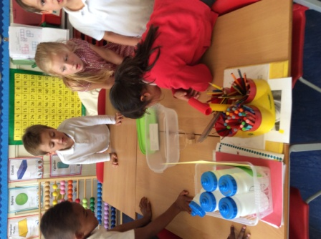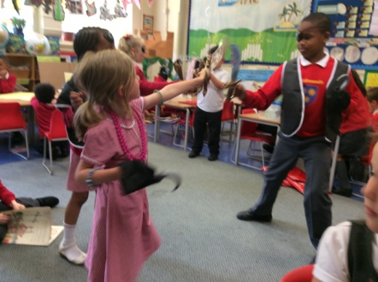

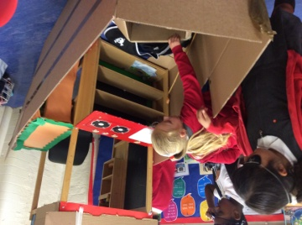

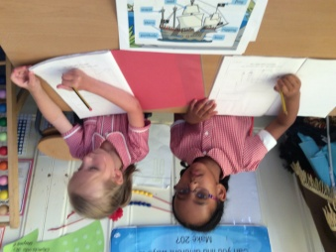

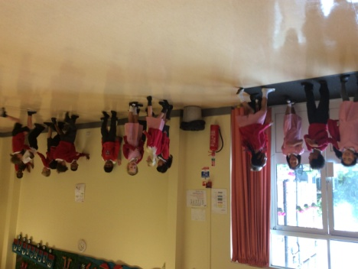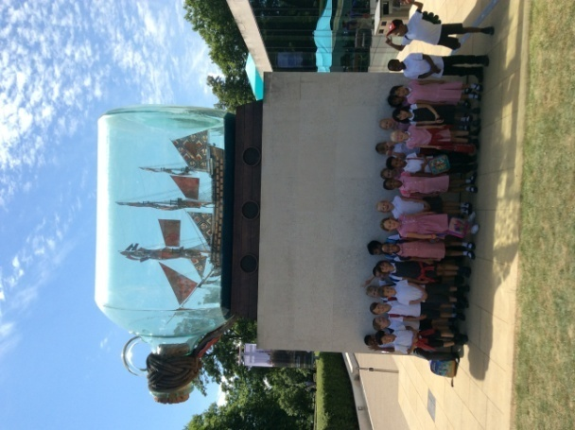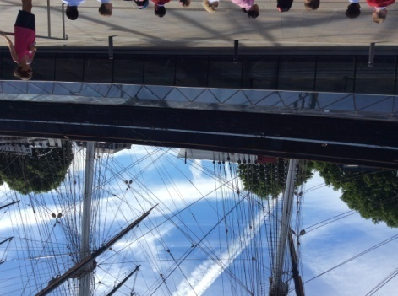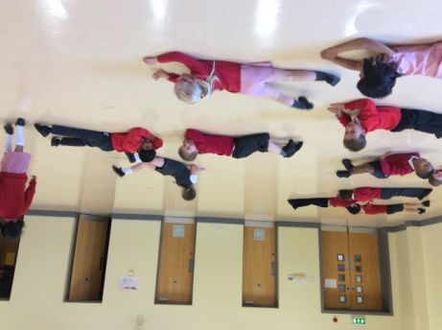

This week, Year 1 went to the Cutty Sark to learn more about life on a real ship. We drew our own observational drawings of the ship, then we went inside to learn more about the ship.

We have been following the captain’s instructions for PE. We had to listen carefully to the instructions.

We have been investigating materials. We looked at which materials could float, which sank in the water, which materials were absorbing the water and which materials were waterproof. We used our findings to design our own pirate ship using these materials.

Our new topic is ‘Pirates!’ We have had a fantastic time pretending to be pirates. We have found out our new pirate names, using our initials.

We also wrote about what life would be life if we were a pirate, what we would wear and what we could do for work.